

**GENC CAPSTONE -**

**FINAL PROJECT**

DONE BY :

Bandi Yuktha Reddy

EMP ID: 2319933

COH ID: CSDAIA24AZ002

**Requirements 1 - Data Preparation (use ADF):**

**1. Loading Raw Data:**

* The source data will be loaded into the raw container in ADLS in zip file format.

**2. Unzipping and Loading Data into Staging:**

* Unzip the files that have arrived in the last 24 hours from the source.
* Load the unzipped files into the ADLS refine container in the path: refine/<participant_name>/Unzippeddata/file.

**3. Processing and Loading Clean Data:**

* Process or clean the data from the unzipped files using Azure Databricks (ADB).
* Load the processed or clean data under the refined container using either Azure Databricks or Azure Data Factory (ADF) in the form of parquet files.

**Requirements 2 - Data Transformation (use ADB):**

**1. Accessing Data Lake using Secret Keys:**

* Access the data lake using secret keys by creating secrets in Key Vault.

**2. The following are the transformations we have to perform:**

* If date is NULL or blank, give default date as ‘2020-11-28’. Format of date column should be YYYY-MM-DD.
* Remove ‘_’ from column header.
* For timestamp column cast in timestamp & rename with DateTime.
* Put correct date type of each column.
* Combine FirstName, MiddleName & LastName as FullName.
* Add new column InsertDate with insertion date.

**3. Creating Delta Tables:**

* Created delta tables in Azure Databricks and load data in the form of parquet files into the refined data lake container.

**4. Visualization and Analysis:**

* Created visualizations on the cleaned data and generate graphs to understand the data easily.

**Setup Email Configuration:**

* Configure email notifications for pipeline failure and success.
* The email should contain pipeline name, run ID, and failure/success message.

**ARCHITECTURE:**

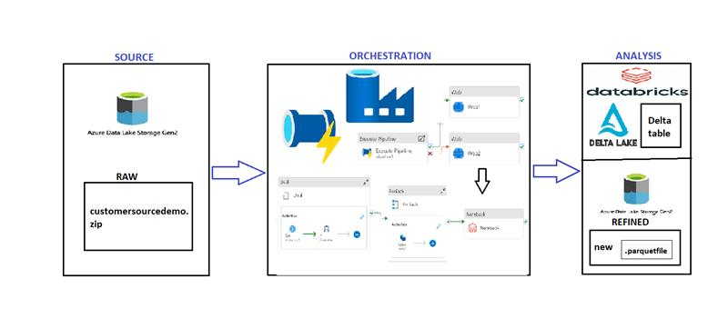

**Problem Statement:**

Load a zip file in raw layer , unzip files into refined container which is staging layer and processed or clean data that has been arrived in last 24 hrs from source & load into ADLS refined container in parquet file as delta table.

**RESOURCES USED FOR THE PROJECT:**

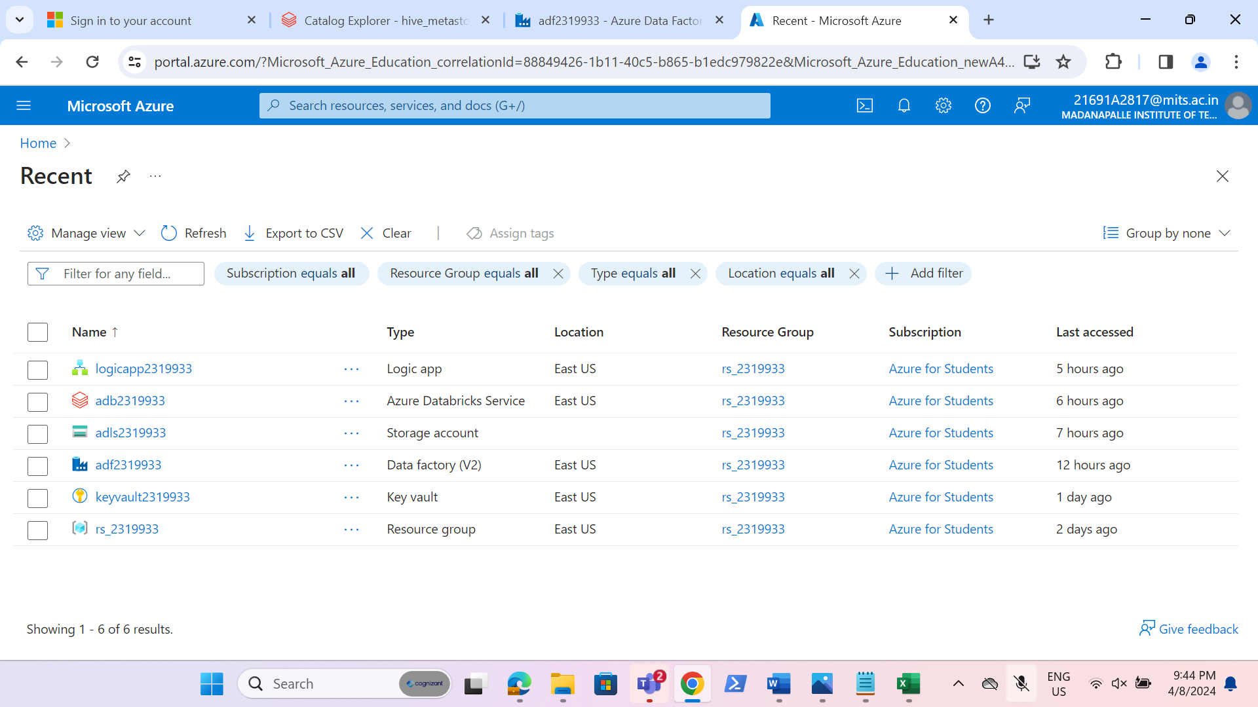

**REQUIREMENT 1-Data Preparation (use ADF):**

1. **Loading Raw Data:**

* Create necessary containers in the storage account.

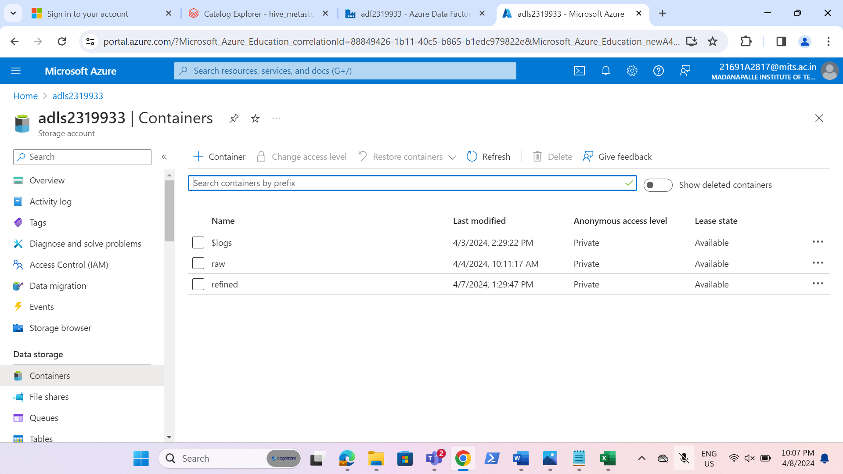

* Upload the file into raw container in zip format.

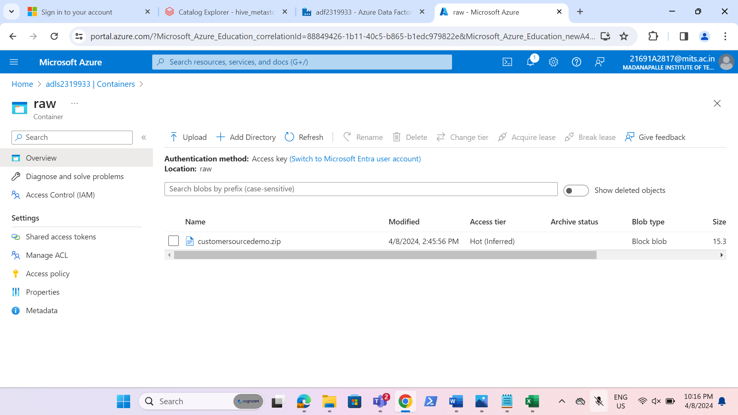

**2. Unzipping and Loading Data into Staging:**

* Check the files that have arrived in the last 24 hours from the source.
* Check if the file is available in the path. If it’s not available, there should be timeout after 1 minute.
* Unzip the files and load into the ADLS refine container in the path: refine/participantname/file.

**Steps:**

* Launch azure data factory to perform all the transformations and checks.

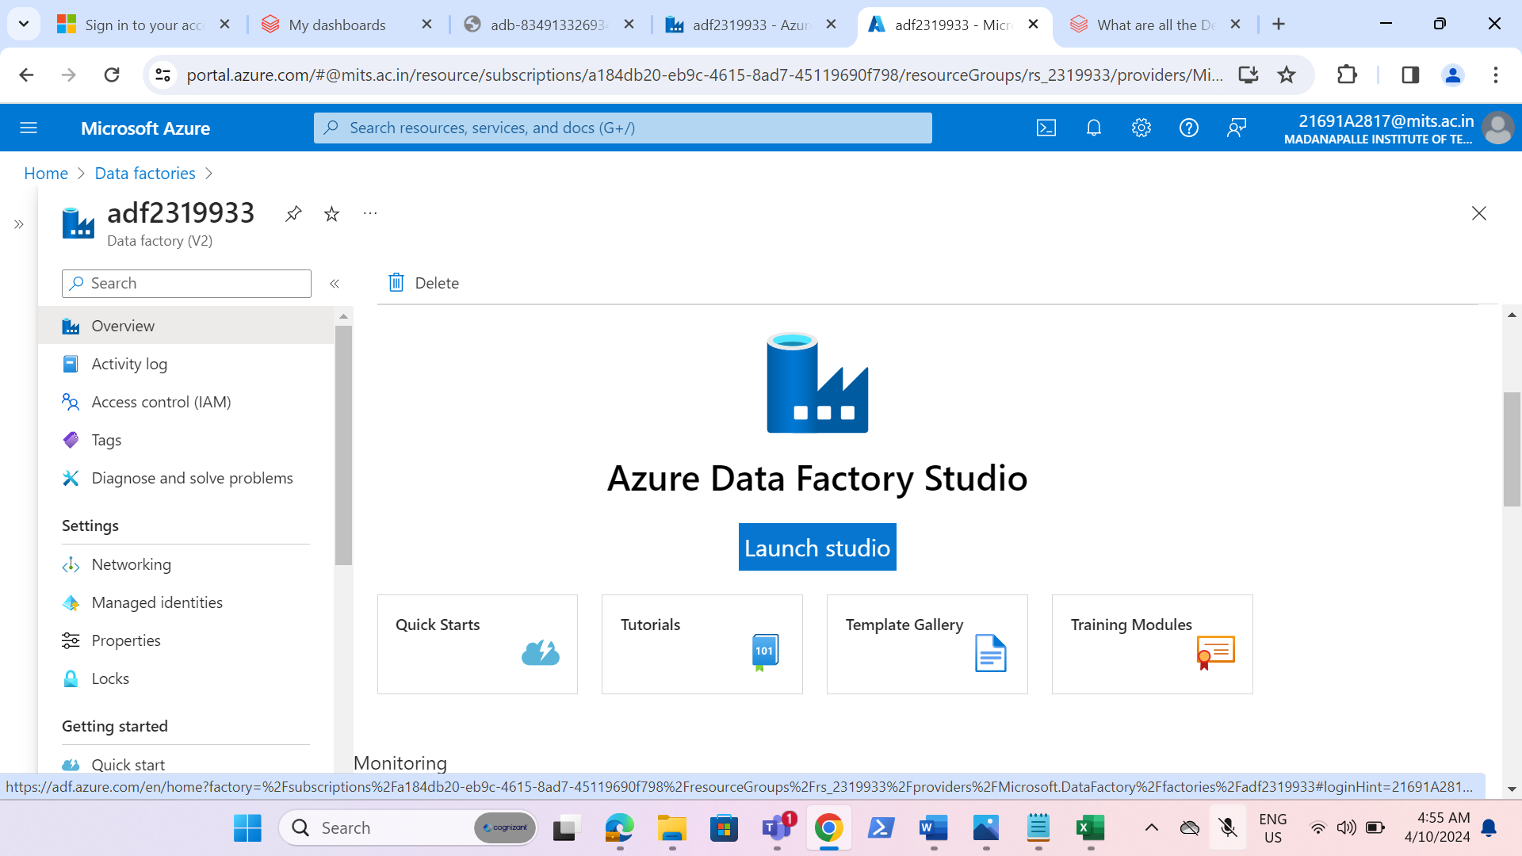

* Create one linked service for the storage account.

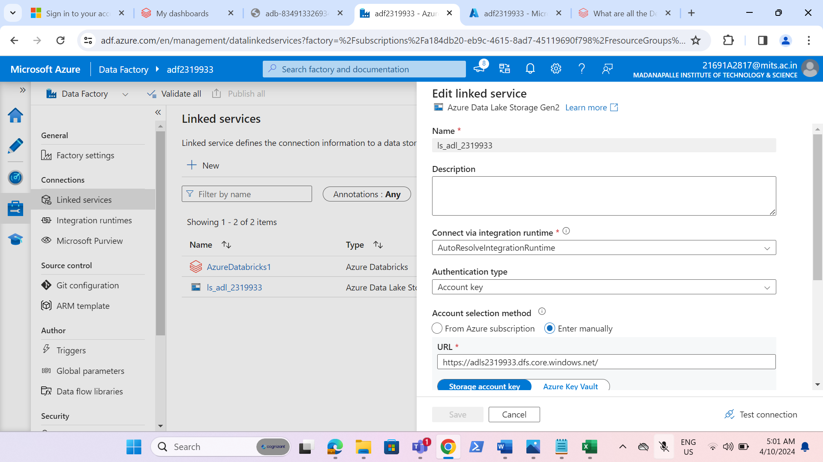

* Created a pipeline named as “innerpipeline2319933” and created a variable named as “Fileavailable” in a pipeline level. Given the expression as “@bool(variables(“Fileavailabe”))” and with a timeout of 1 minute.

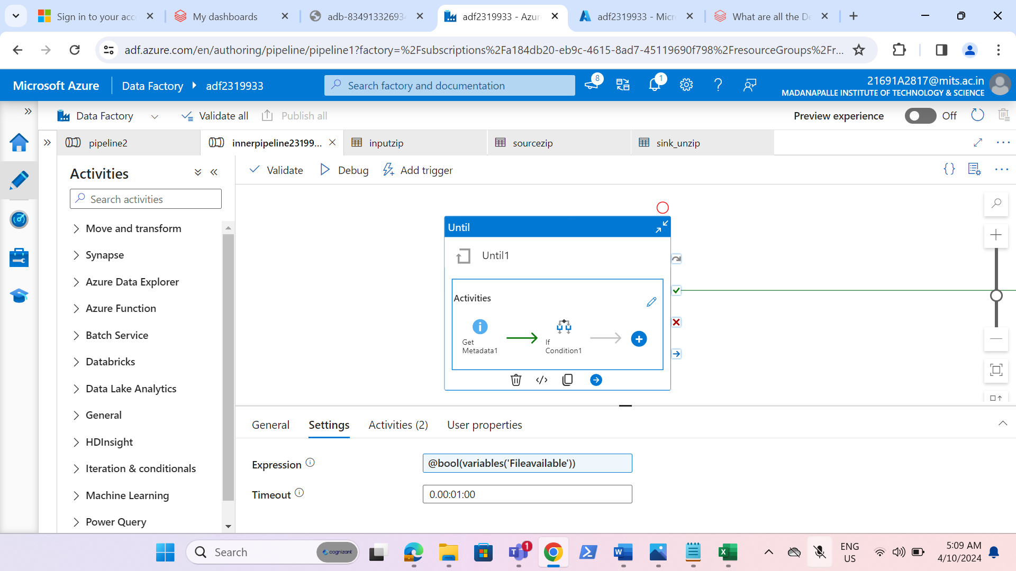

* Added GetMetadata activity inside the Until activity and the field list to check the files that are loaded within 24 hours or not.

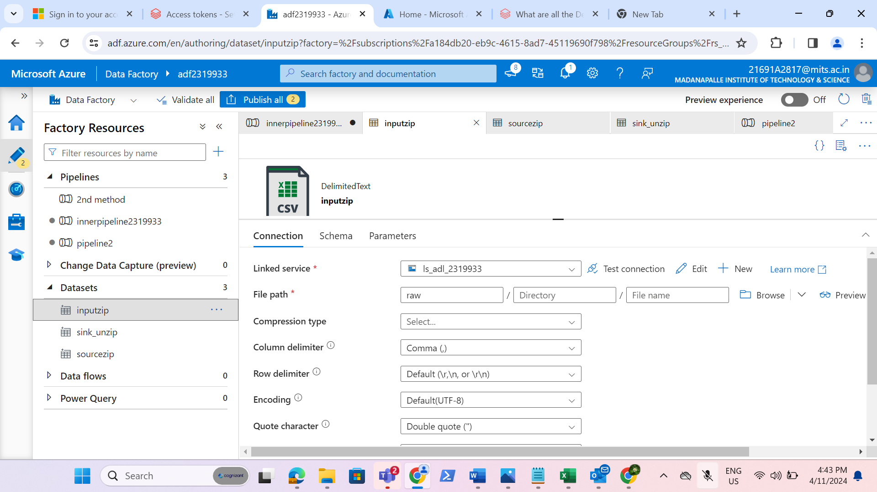

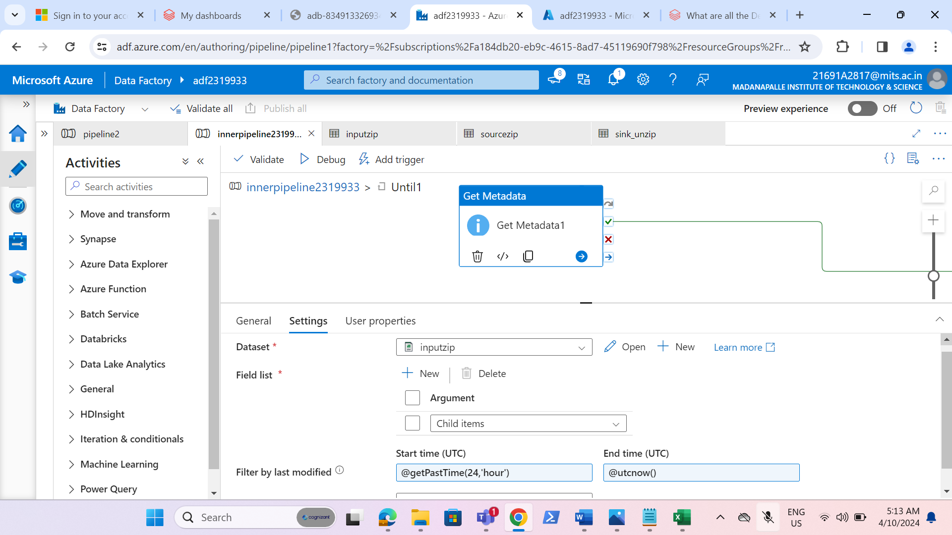

* Added “if condition” activity on success of get meta data activity and passing the expression to check whether any files are present or not.

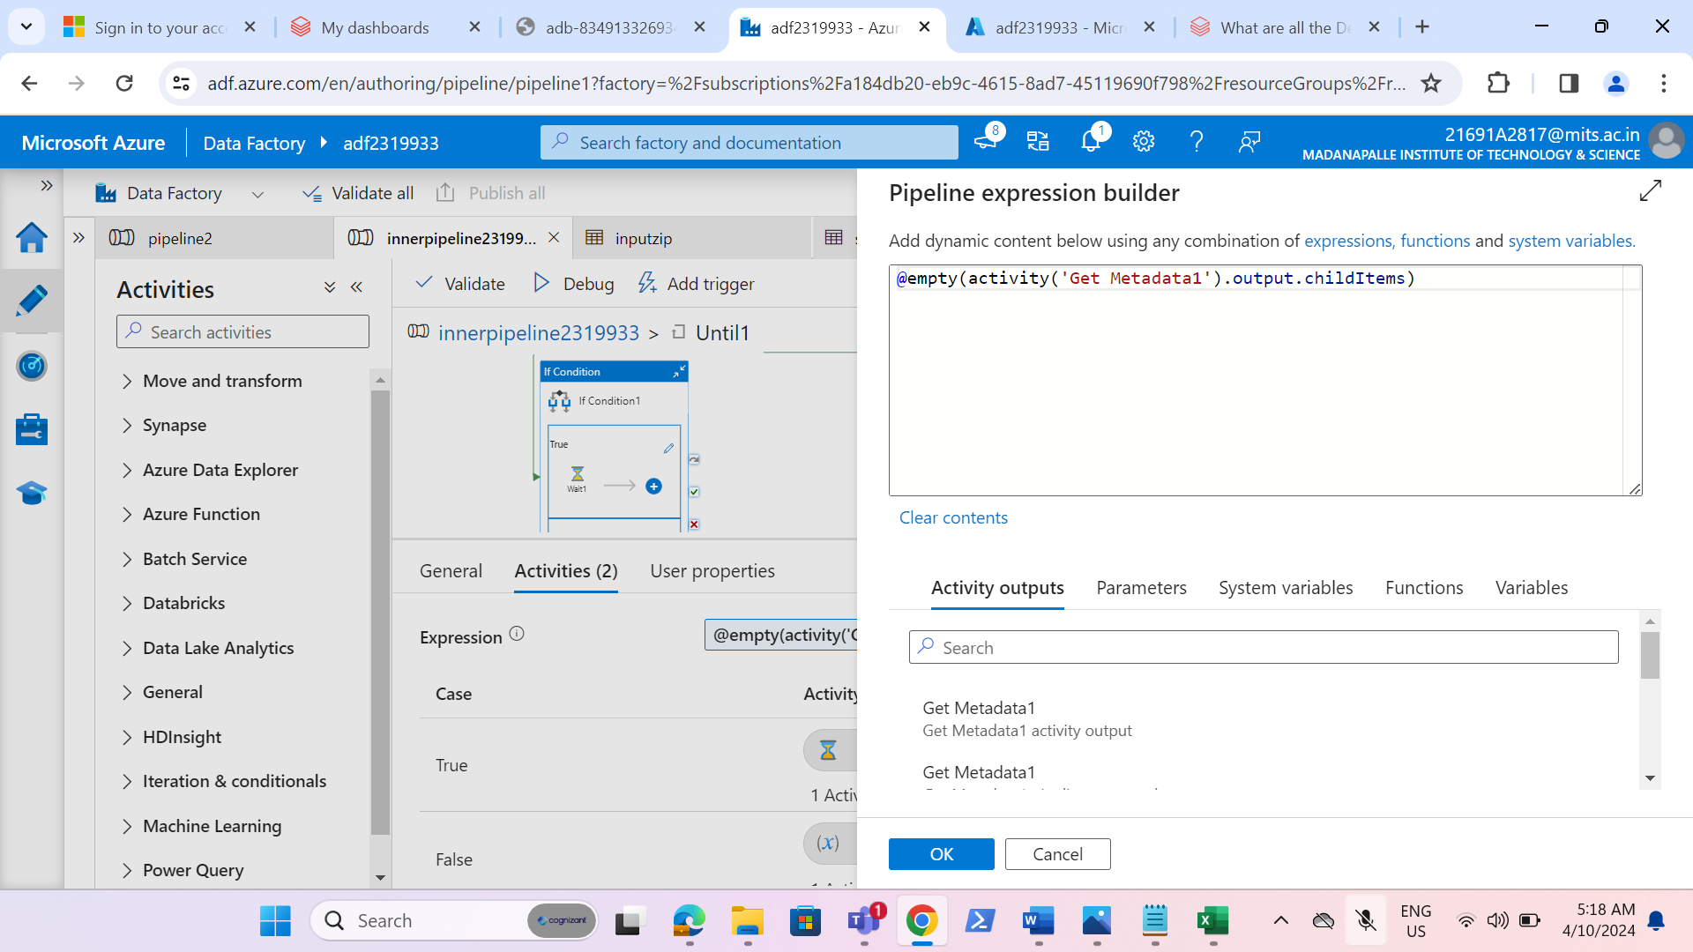

* Now if no files are present it should wait for a certain time and the until activity should fail so we are passing wait activity with in if true activity.

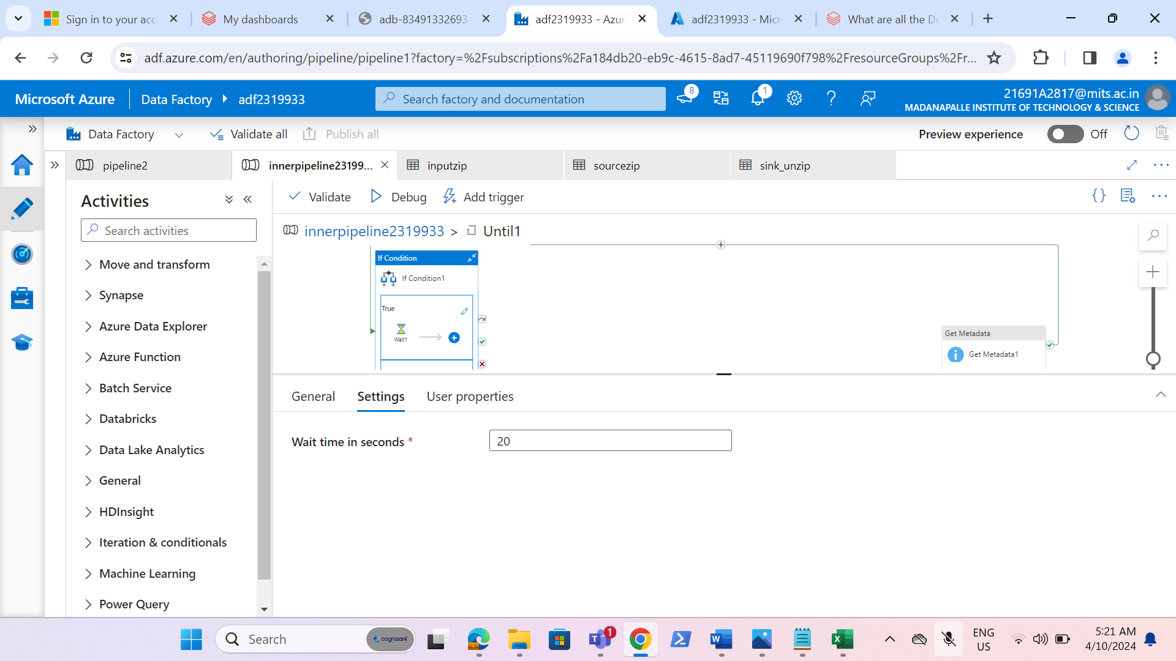

* If any files available the variable should set as true so that further activites can run so we are passing a set variable activity to set the value true in false activity.

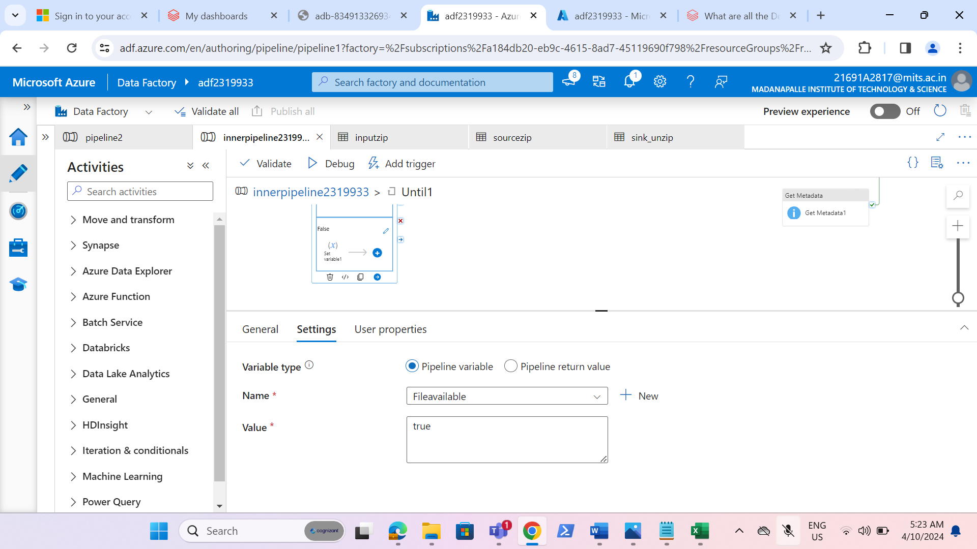

* Now, add foreach activity and given the output of metadata activity to it.

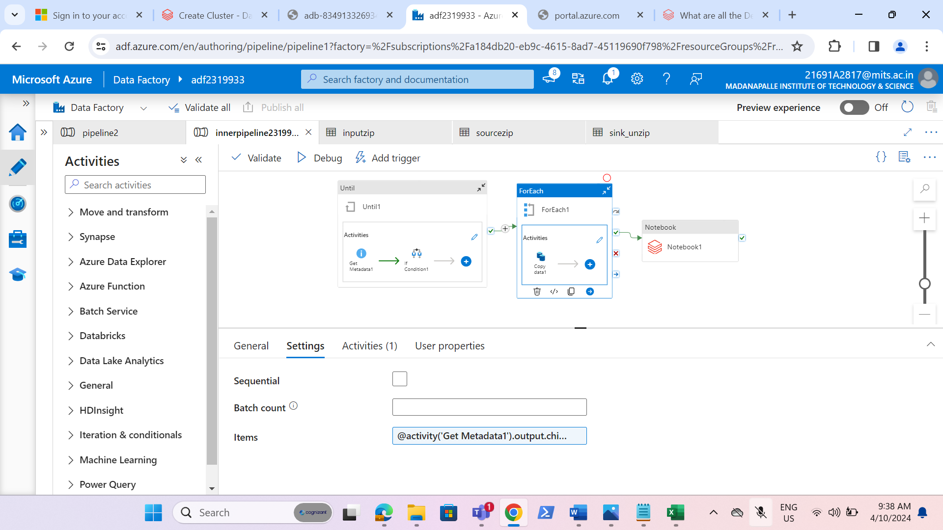

* Created the source dataset named as “sourcezip” for copy activity inside the foreach activity and created the parameter to access the file dynamically.

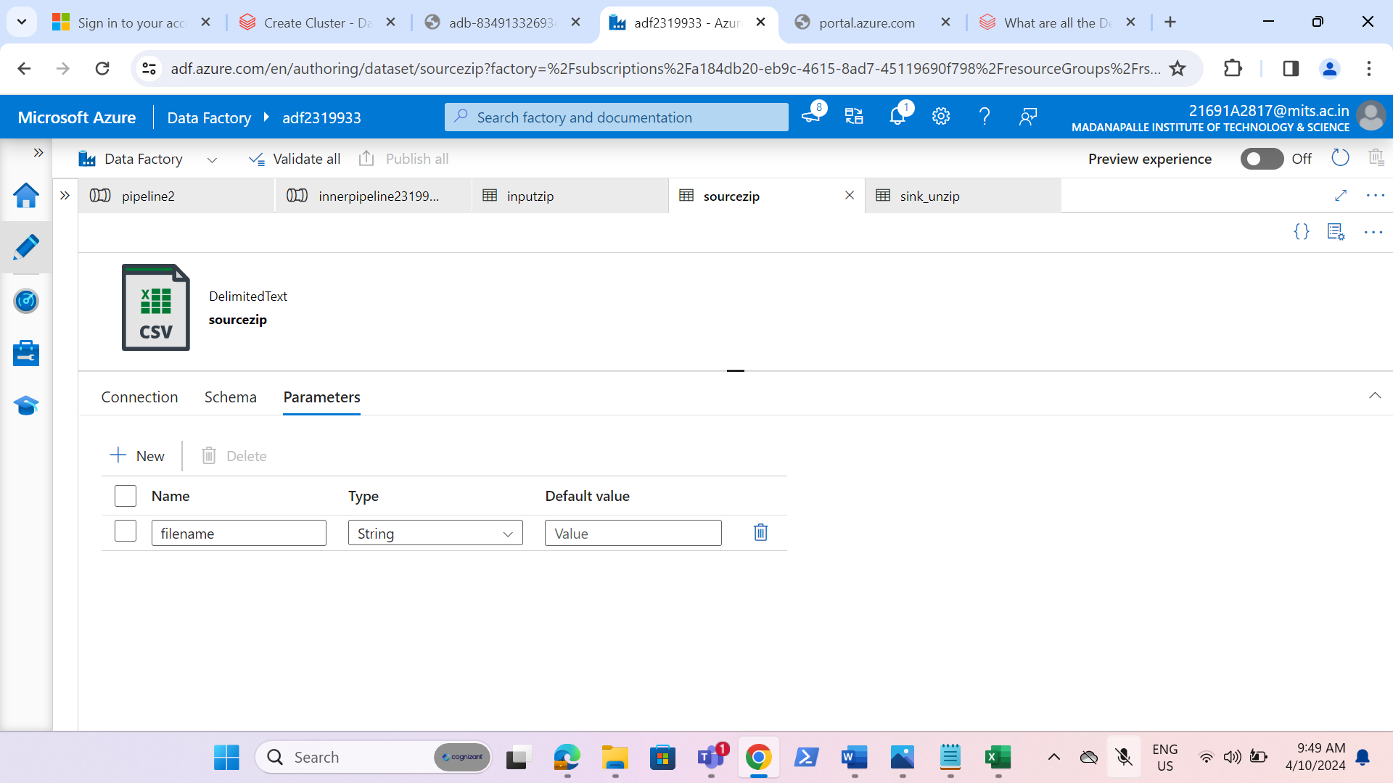

* Dynamically defined the file path.

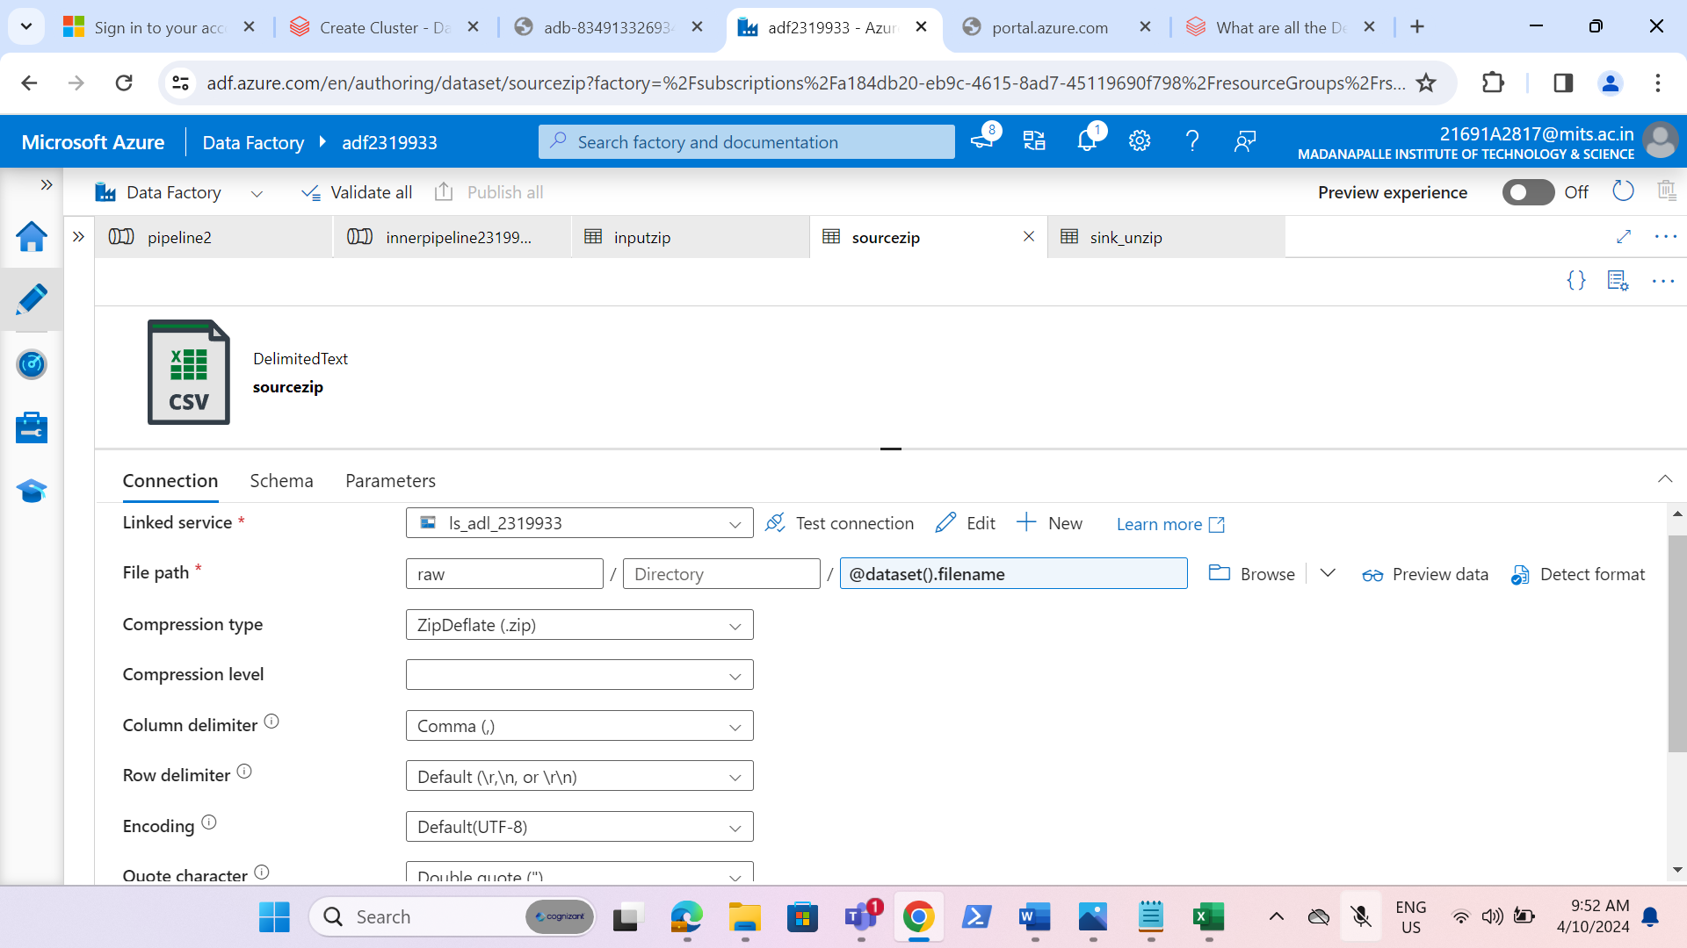

* Created a sink dataset named as a “sink_unzip” for copy activity inside foreach activity and pointed the path of container to where the files should be unzipped.

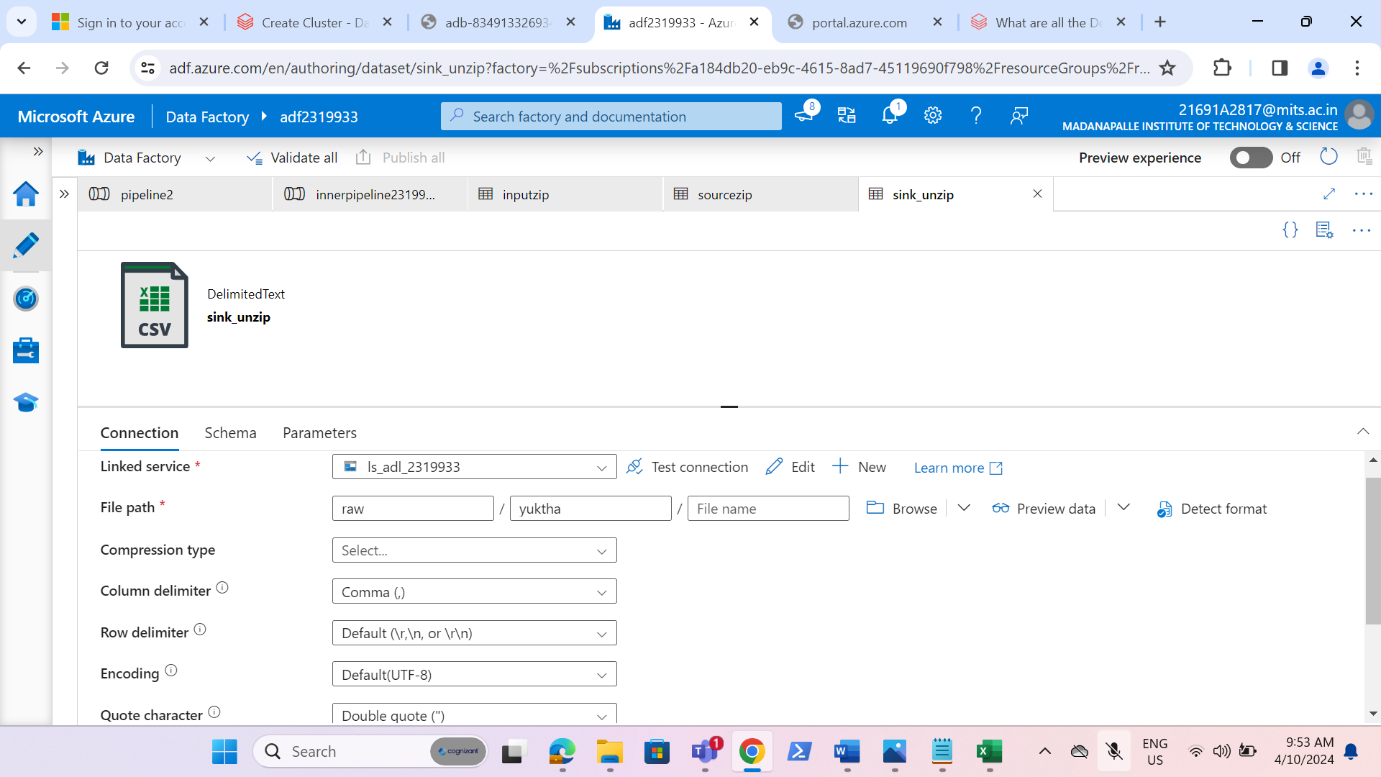

* Now added the copy activity inside the foreach activity to unzip the files.

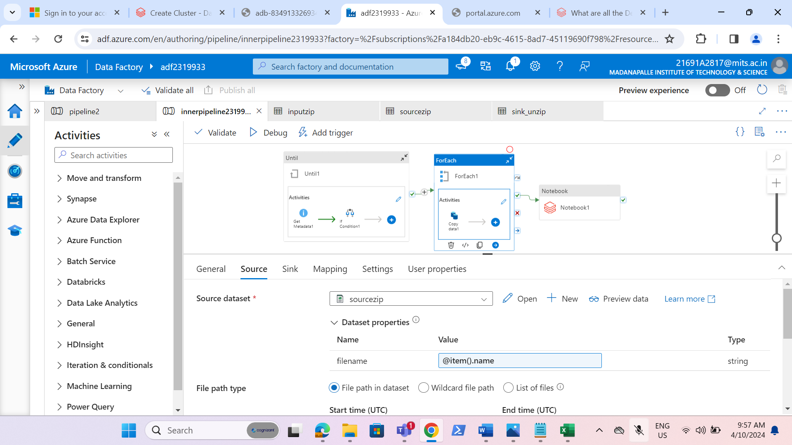

* Now we have successfully unzipped the file with help of ADF.

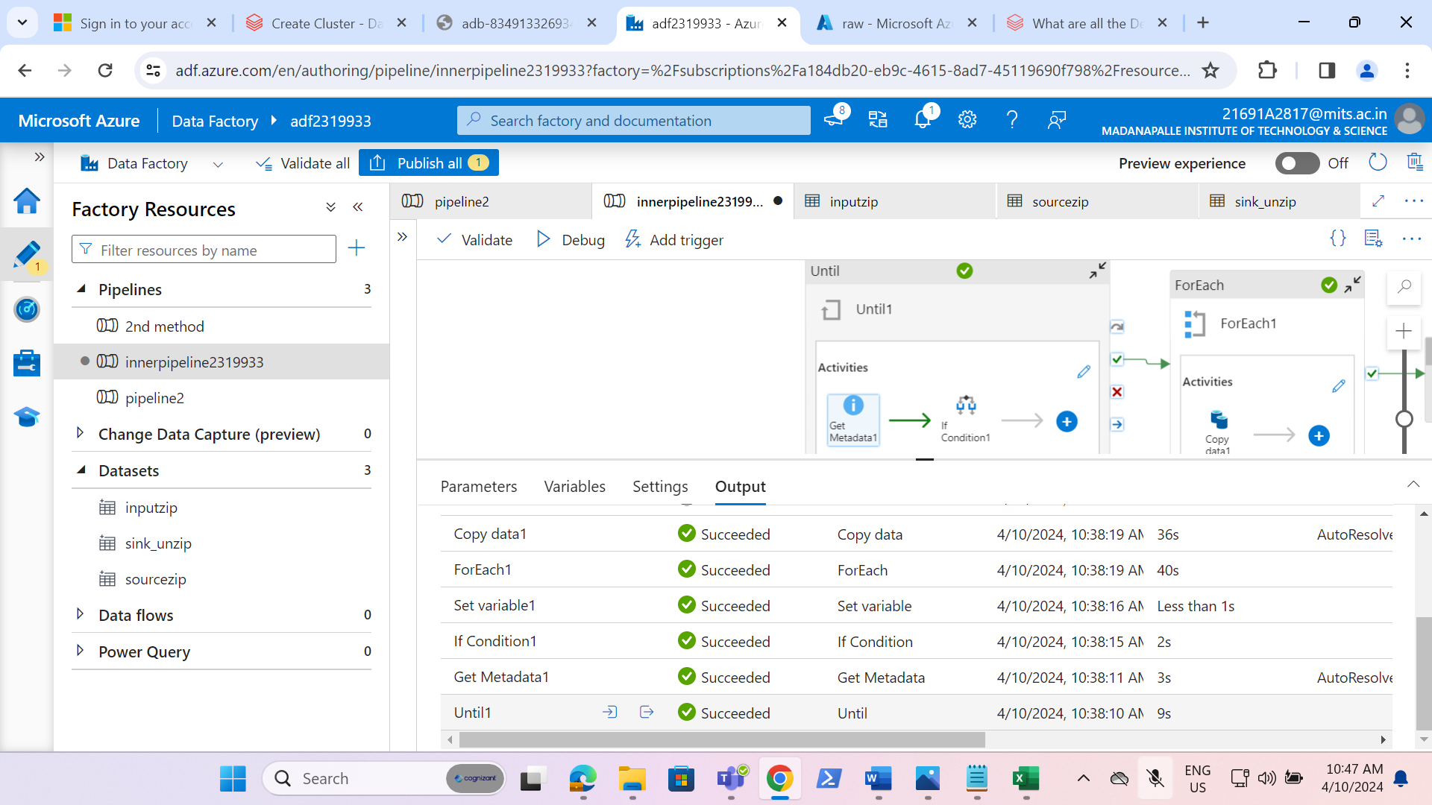

**REQUIREMENT 2-Data Transformation (use ADB):**

**1. Accessing Data Lake using Secret Keys:**

* Access the data lake using secret keys by creating secrets in Key Vault.

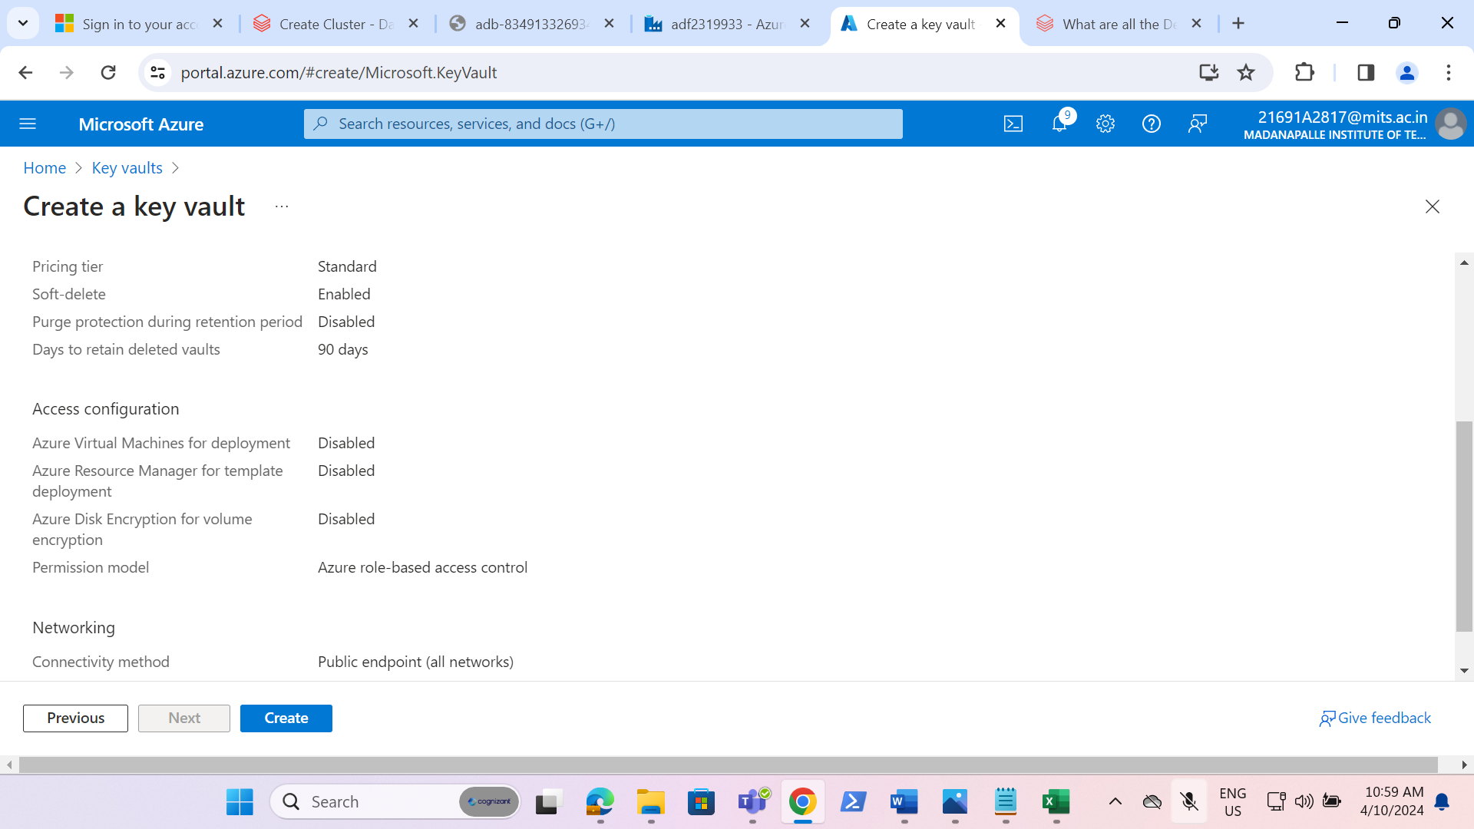

* Created a secret named as “secret2319933”. While creating the secret we have given the secret value as the access key of storage account.

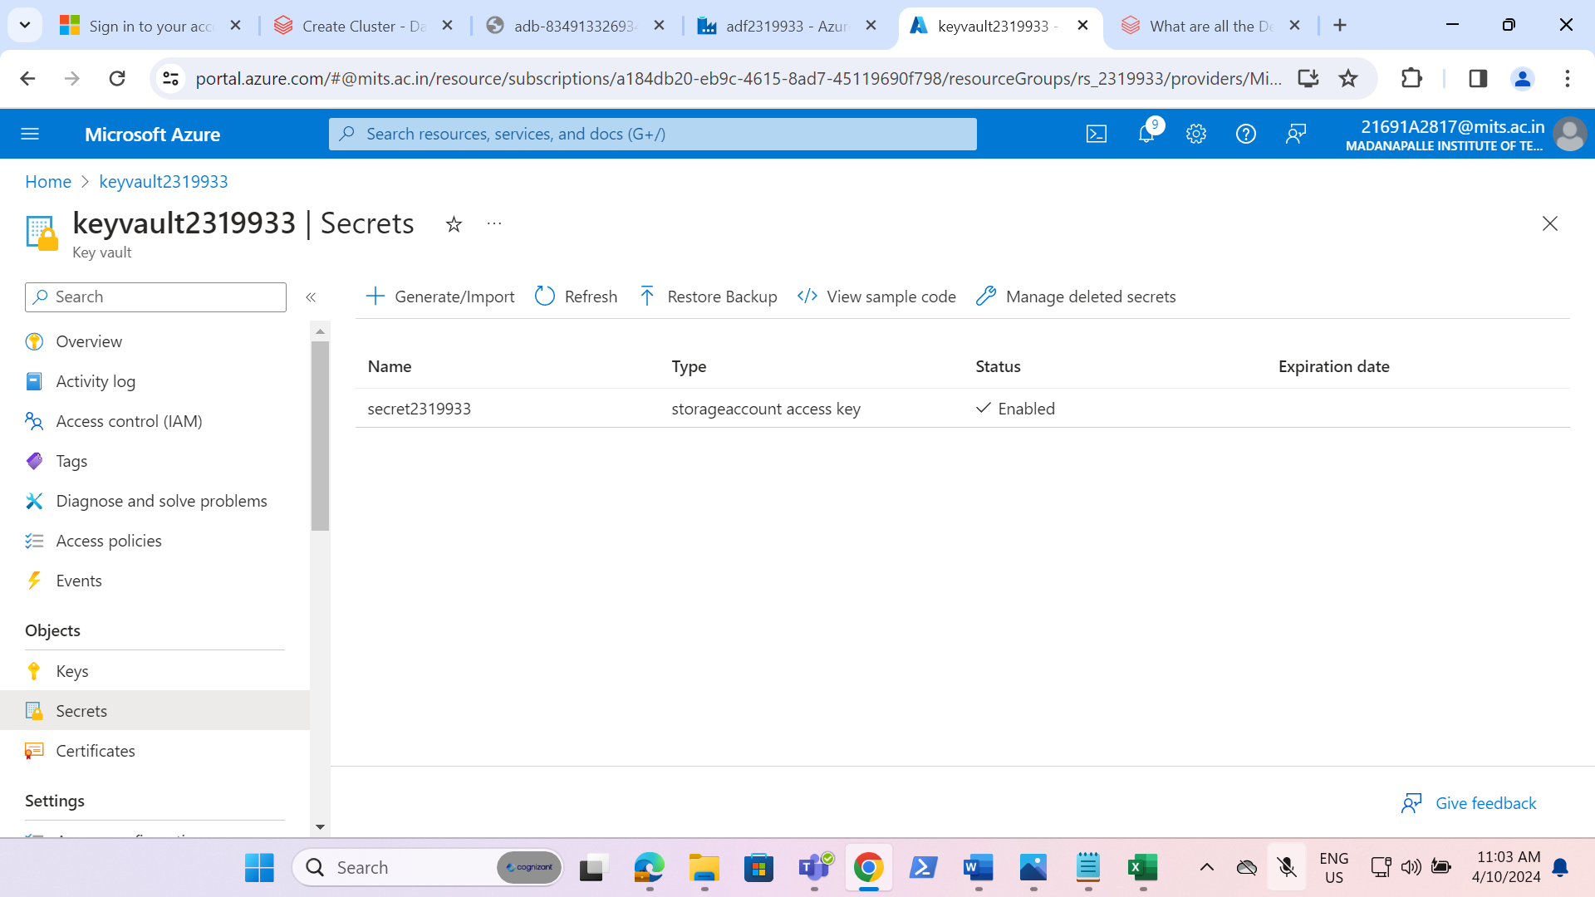

* Created the scope named as “scope2319933” in Azure databricks and given the azure key vault details.

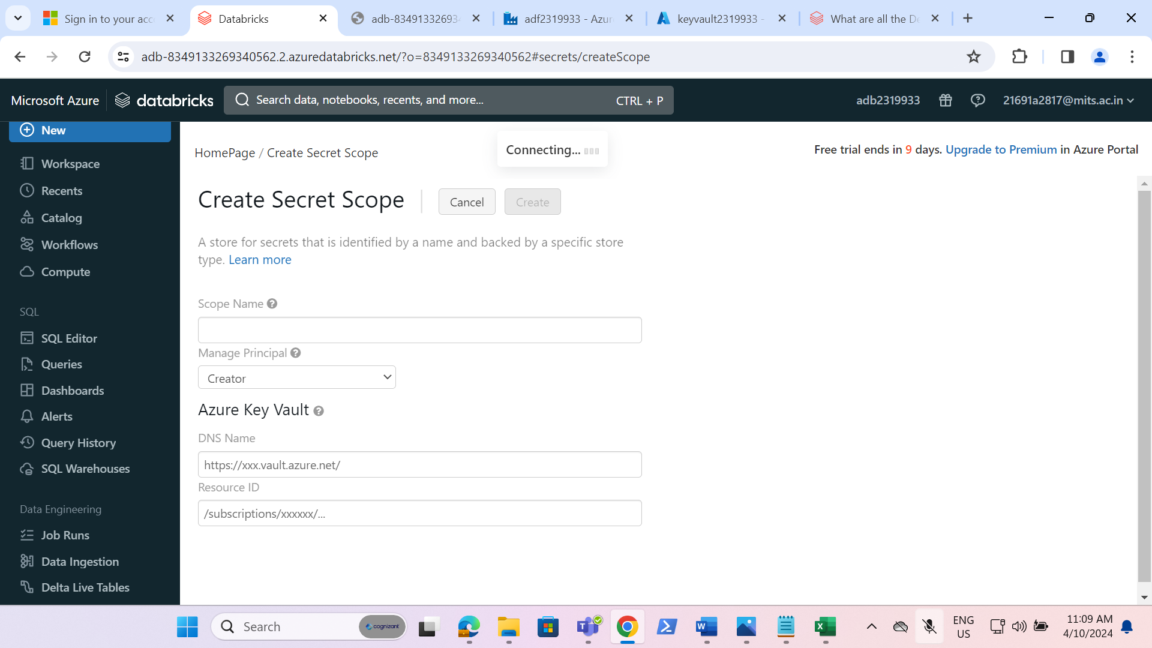

* Created a cluster named as “Charitha K’s Cluster”

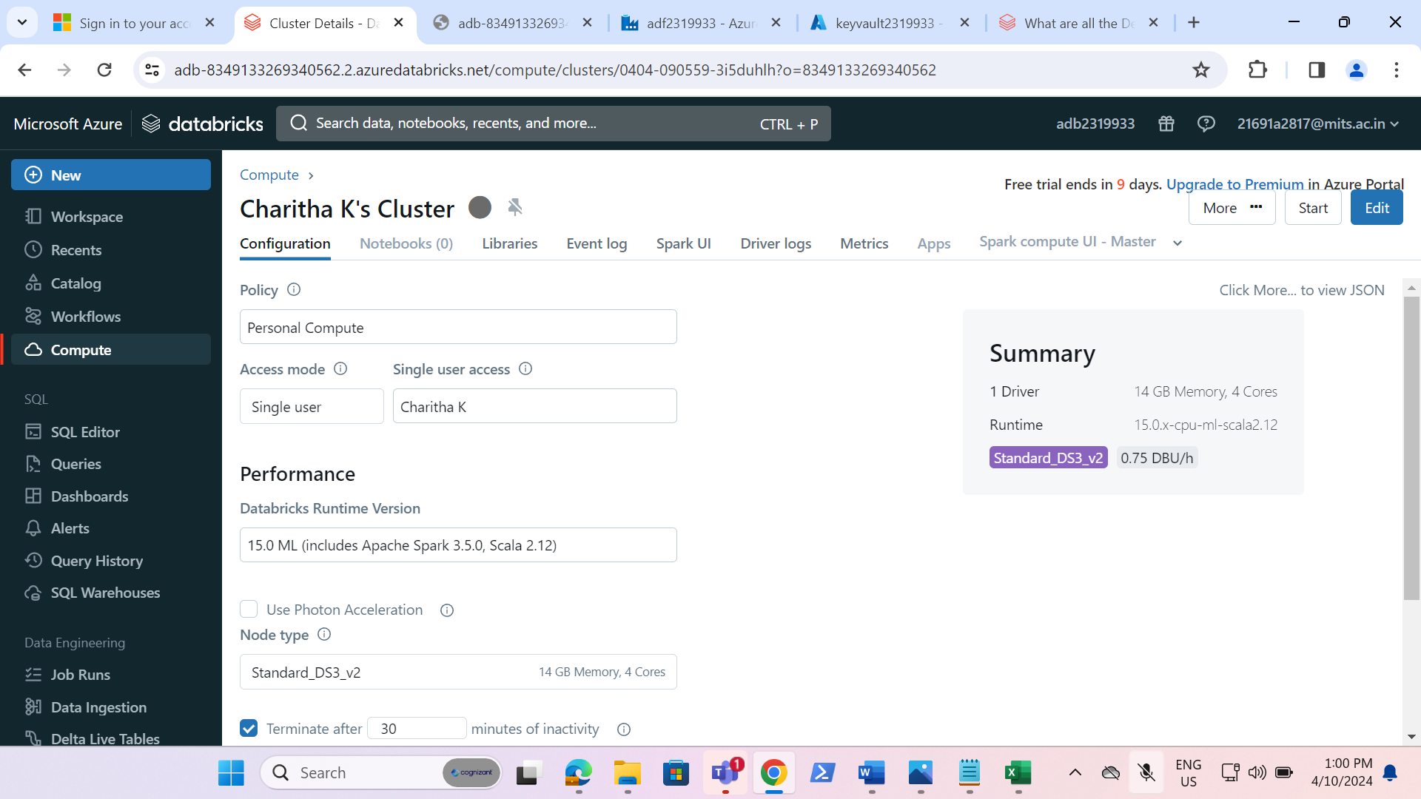

* Created a notebook named as “finalnotebook2319933”

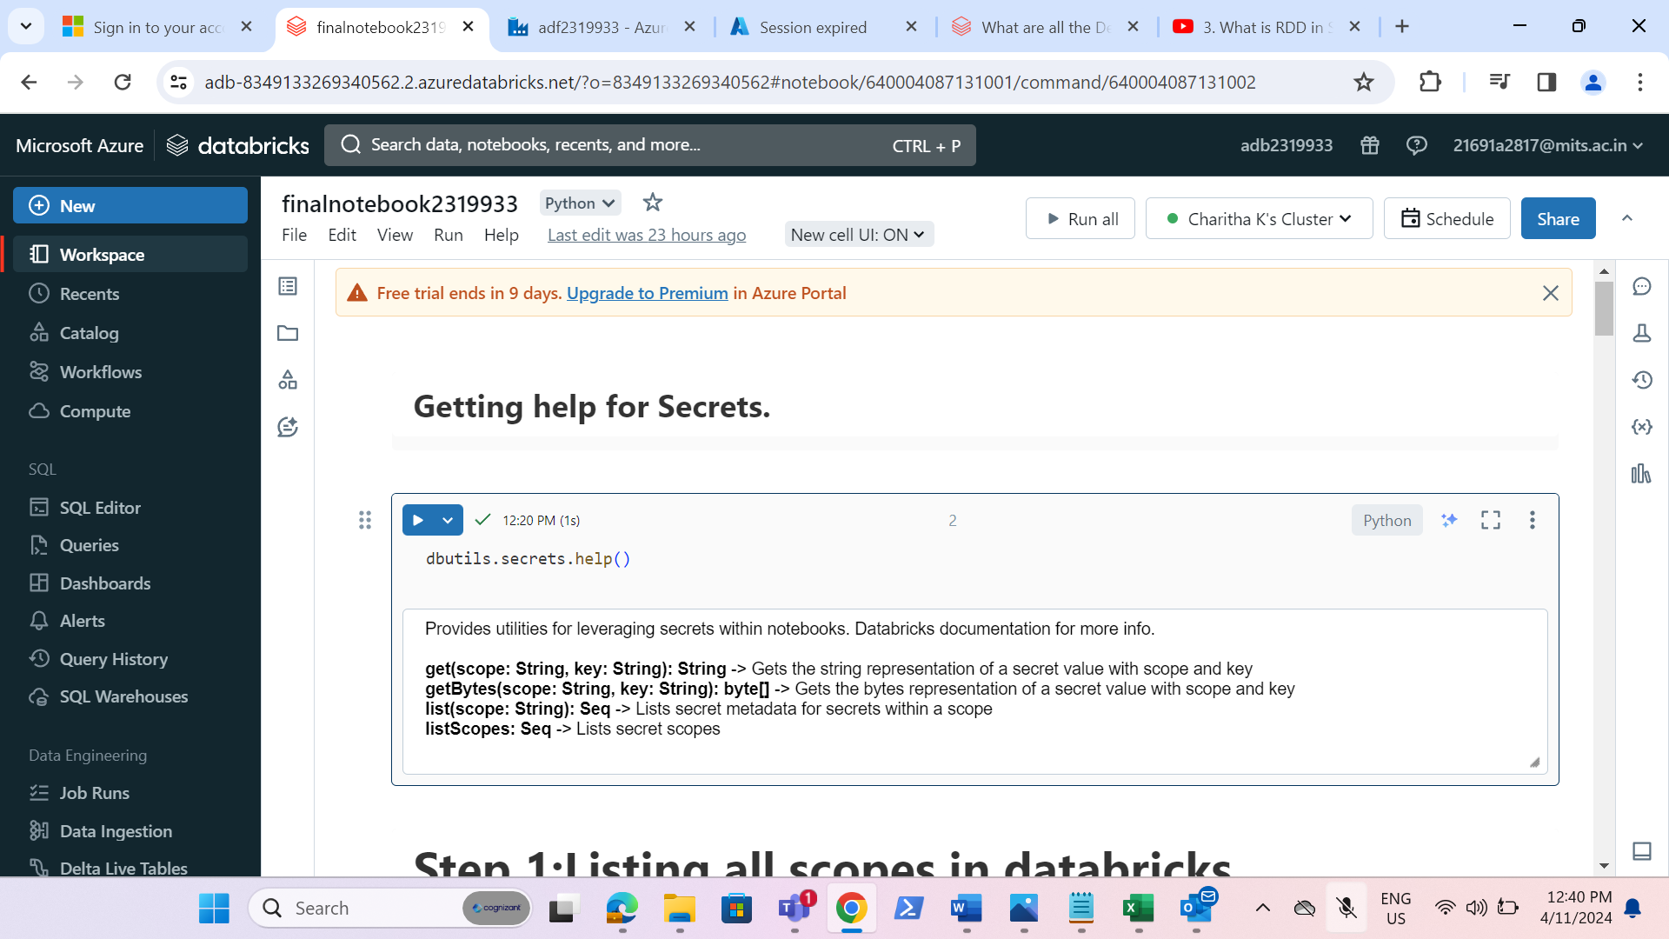

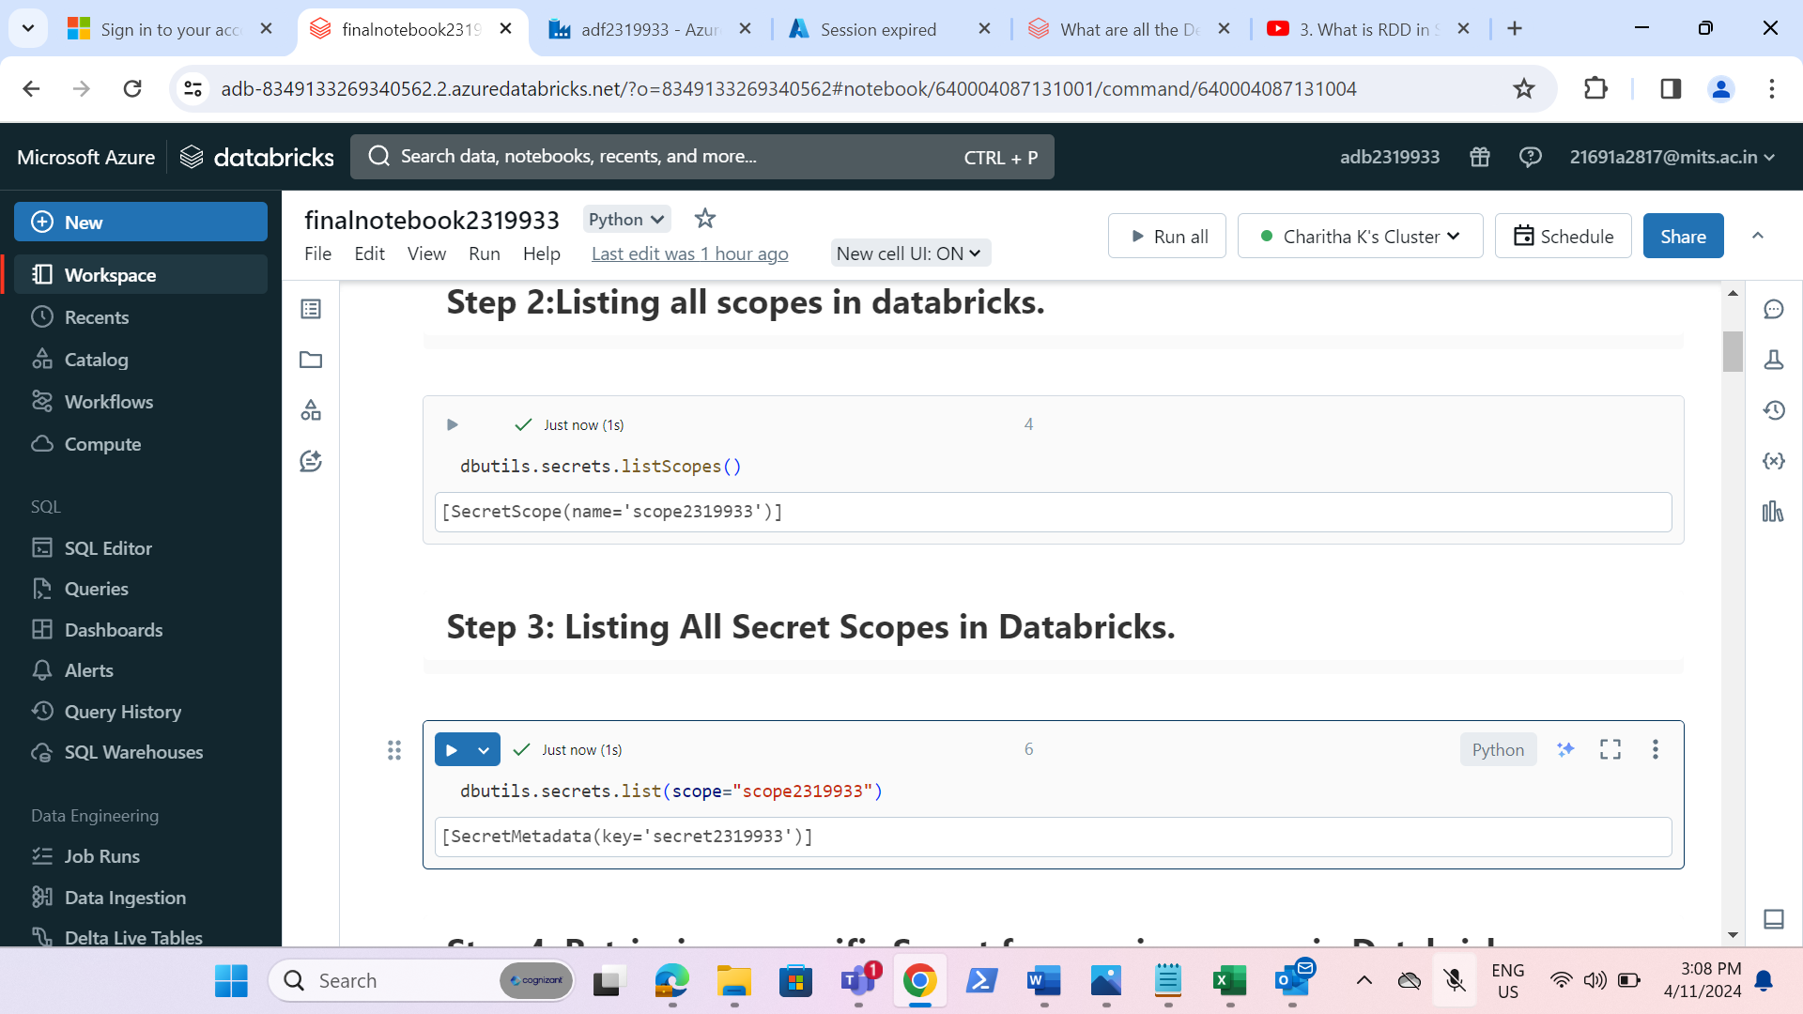

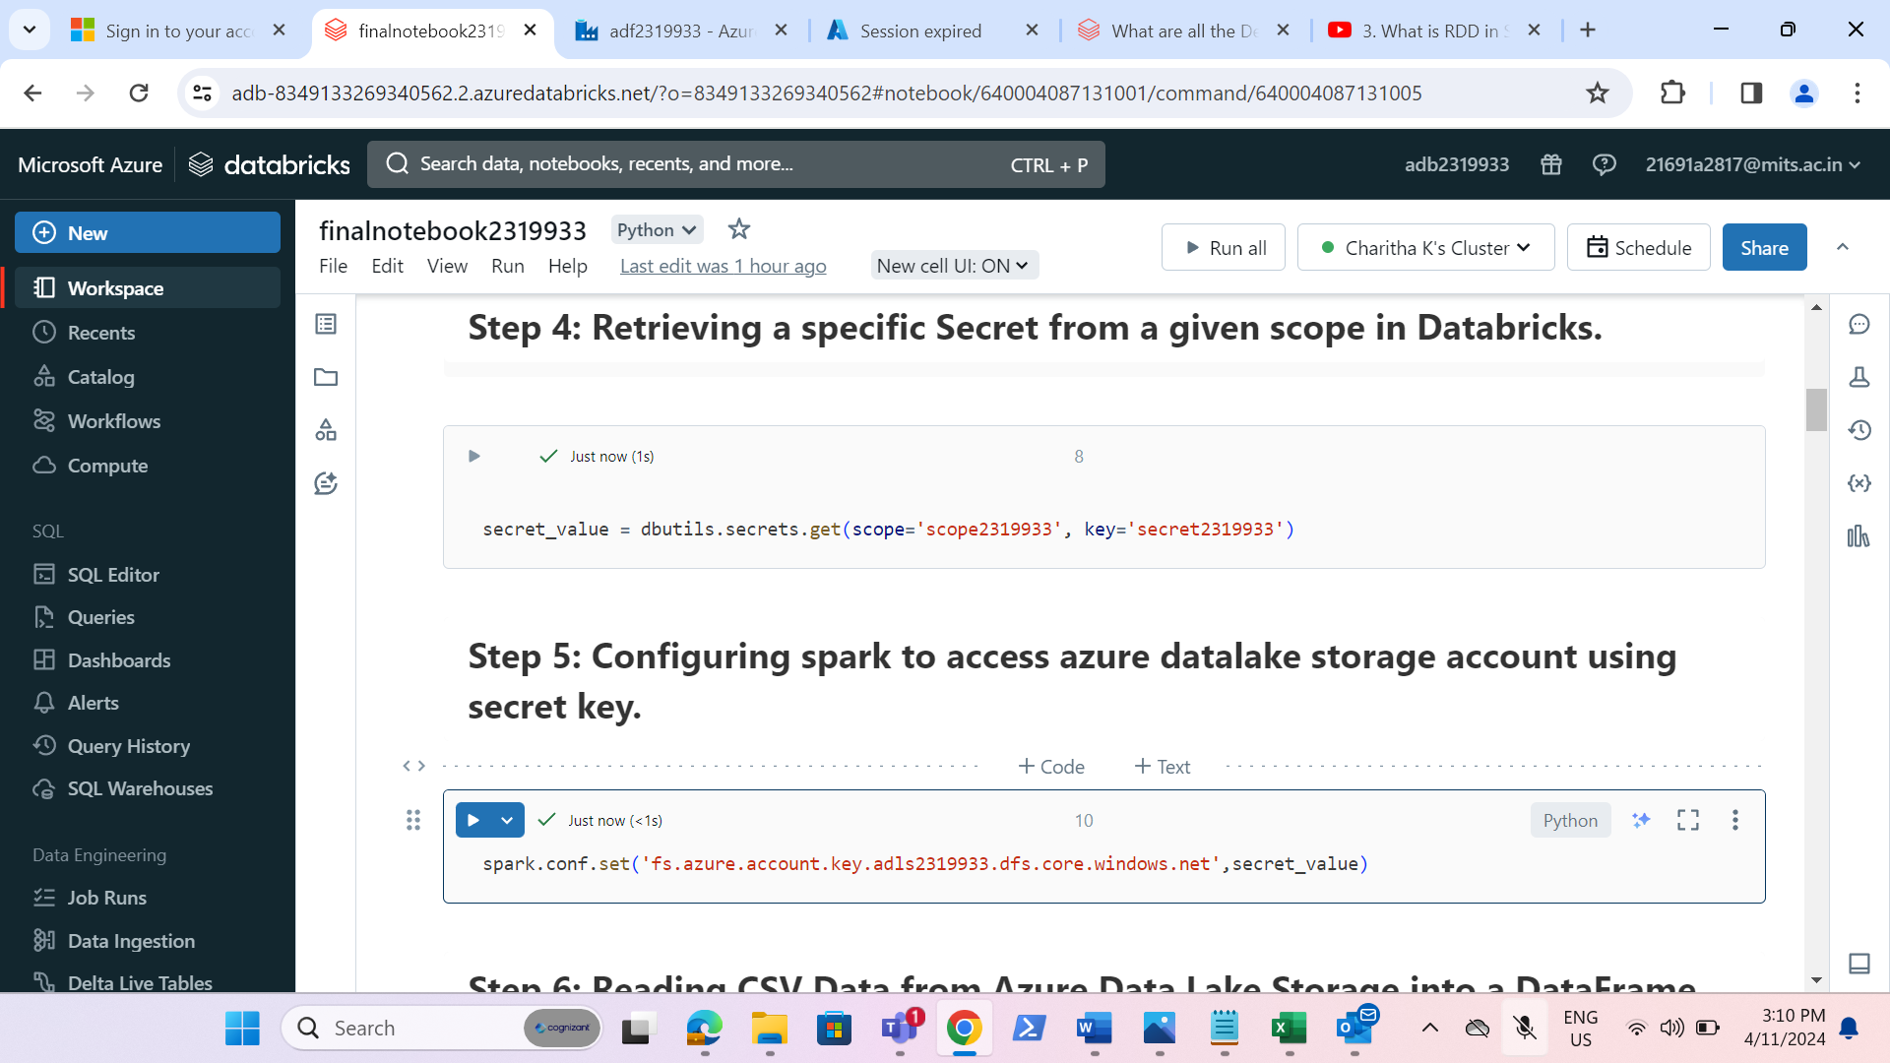

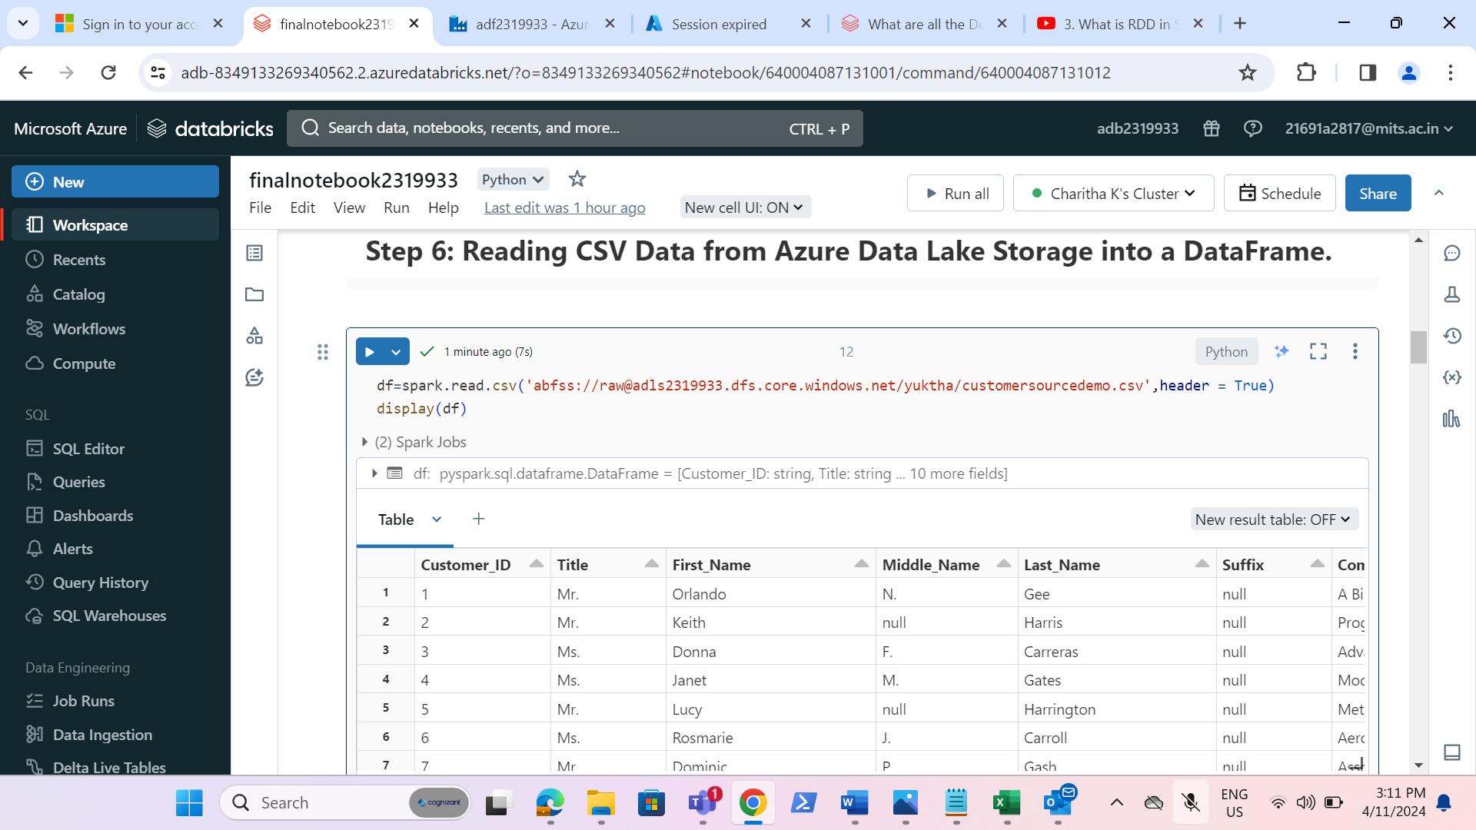

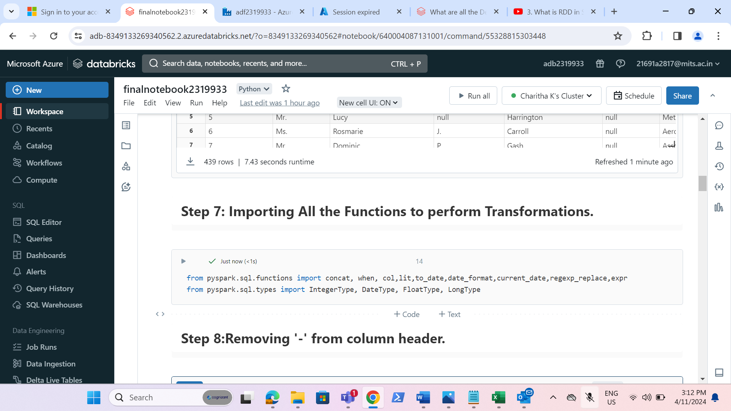

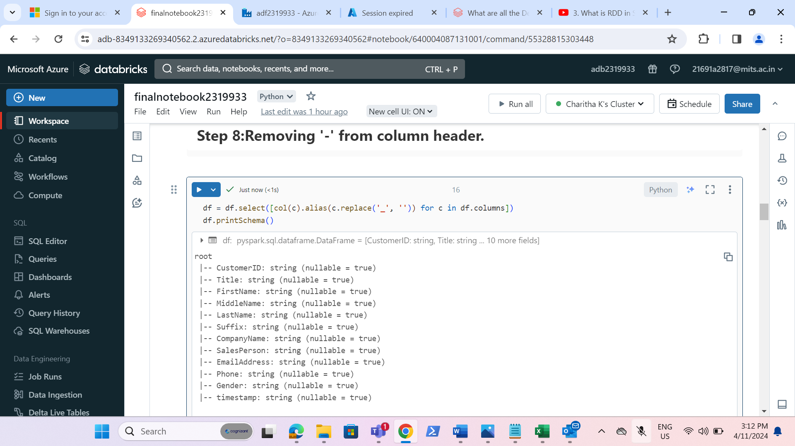

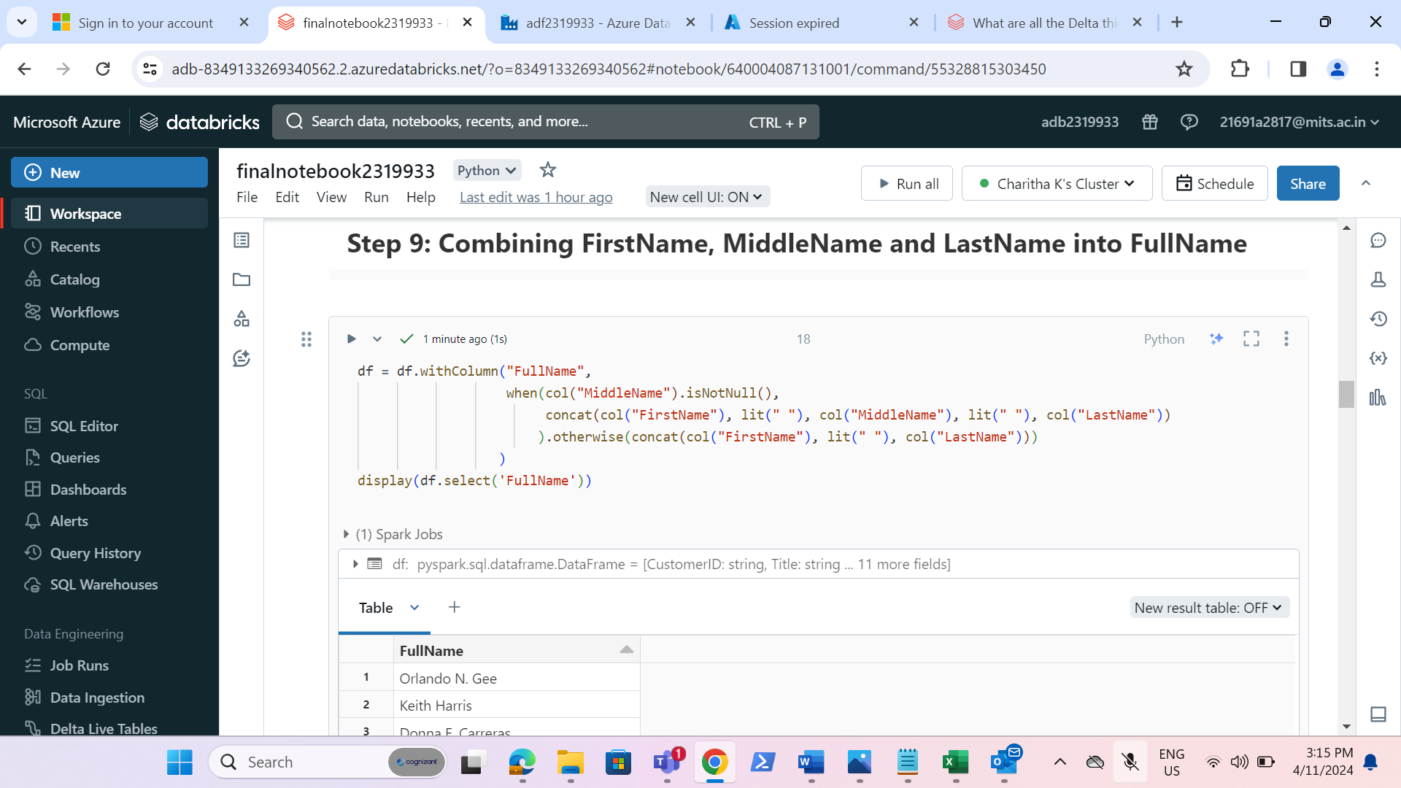

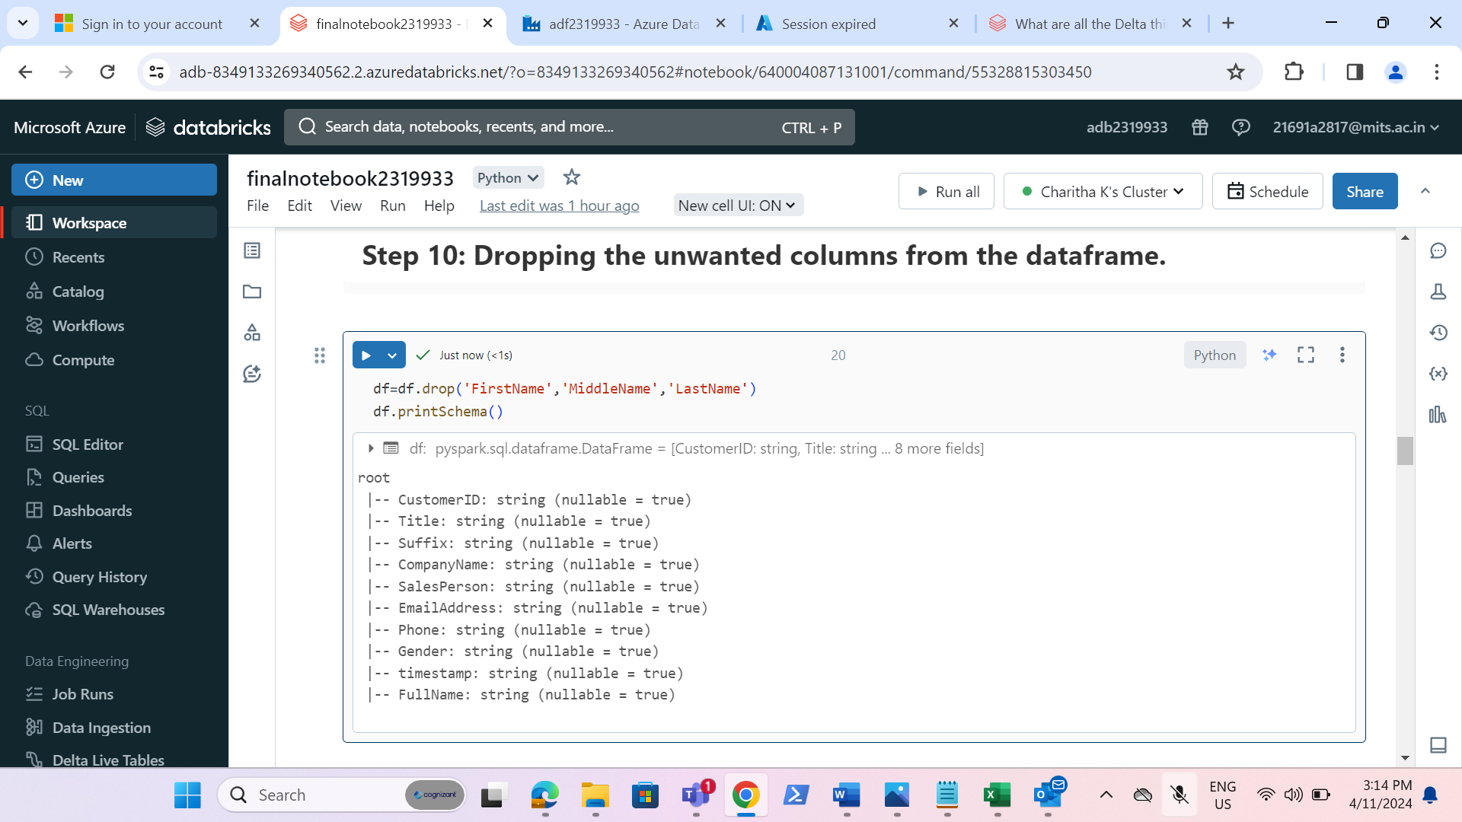

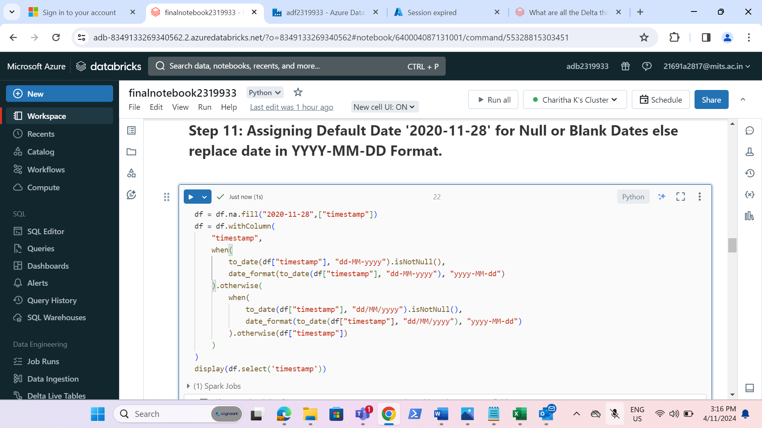

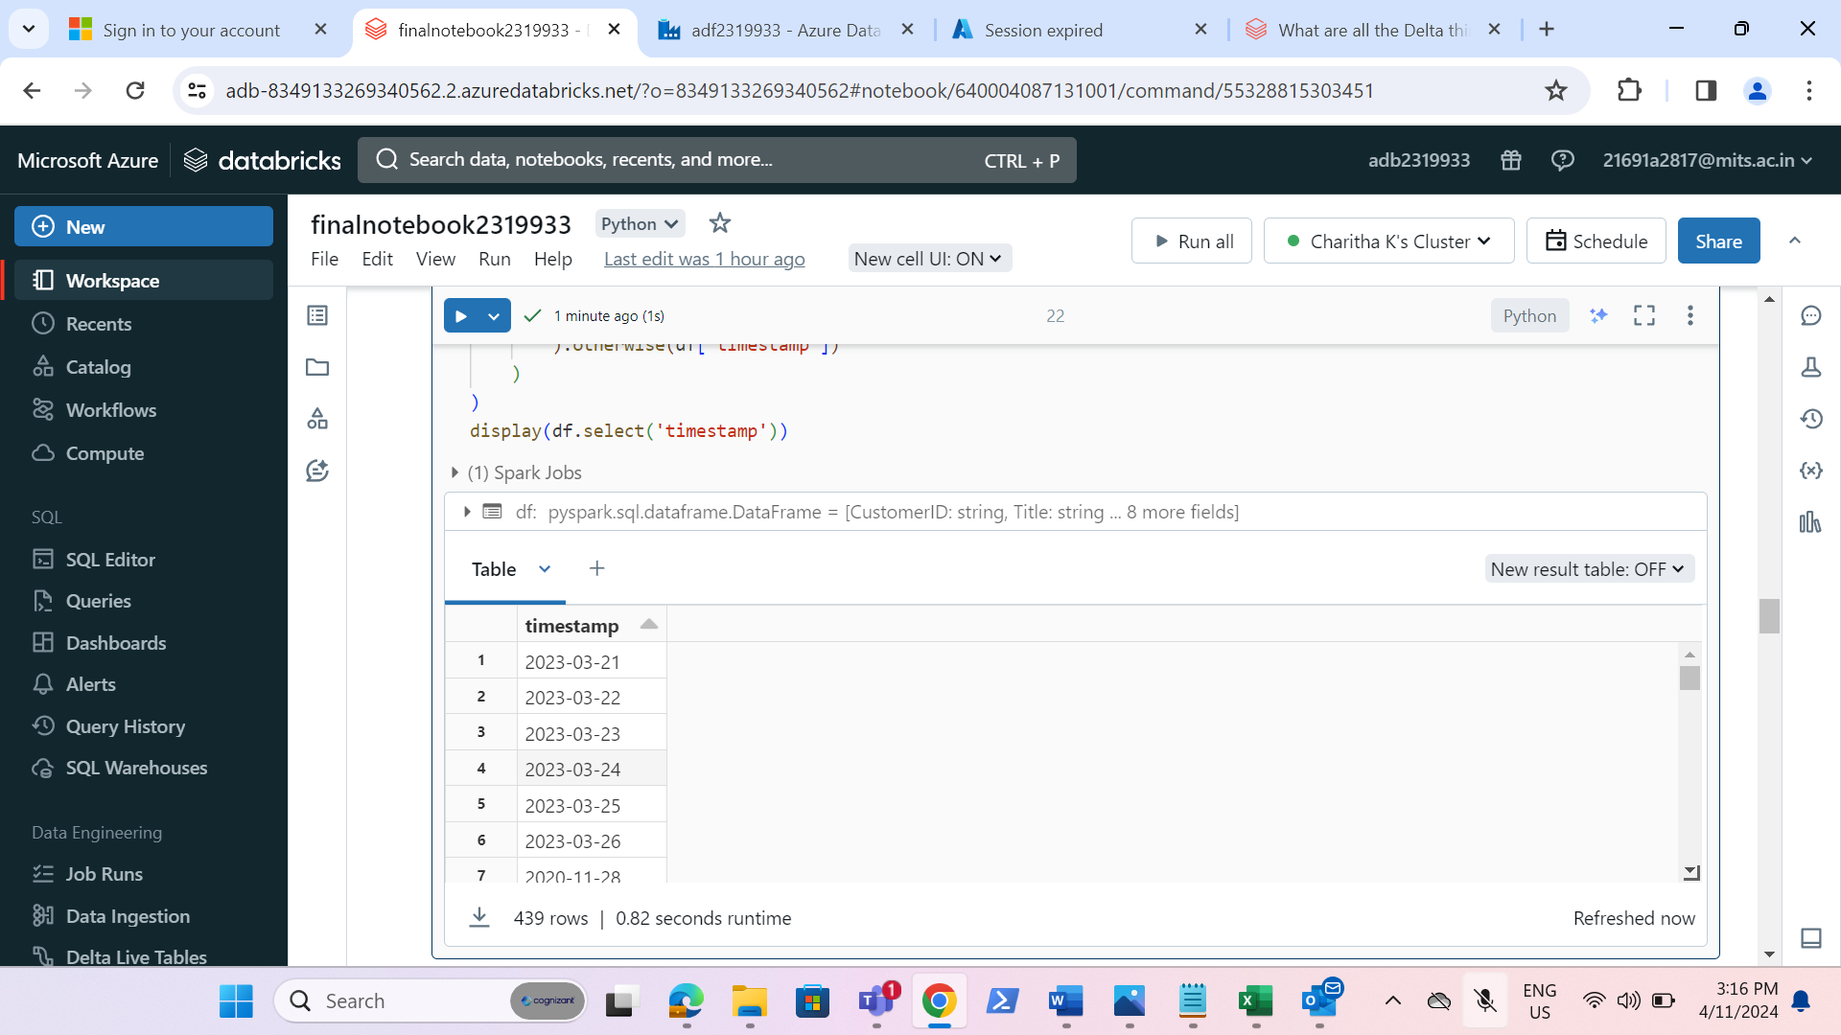

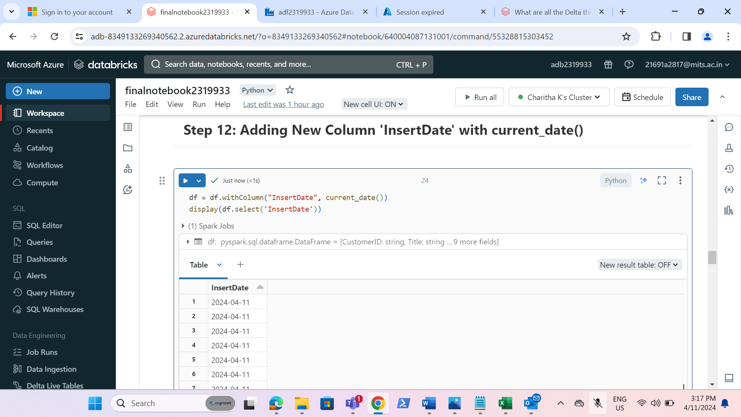

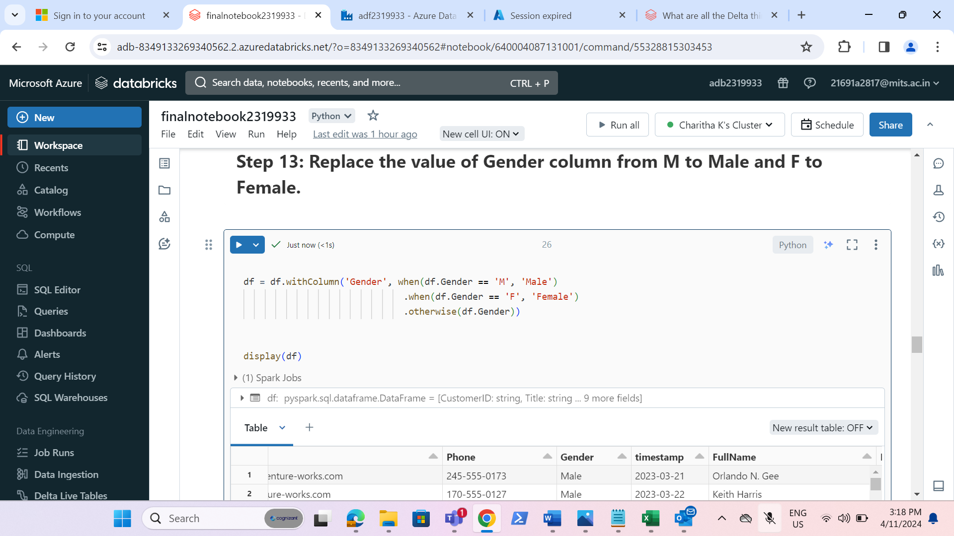

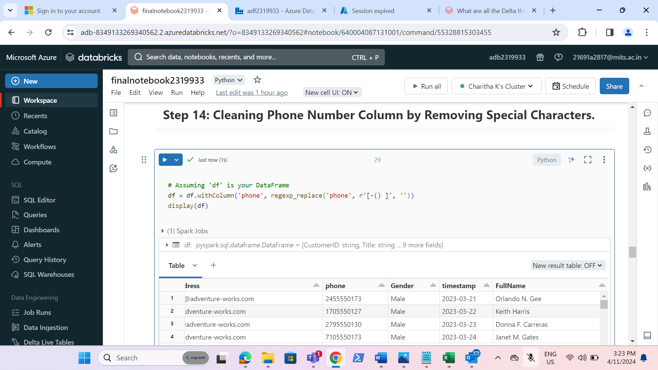

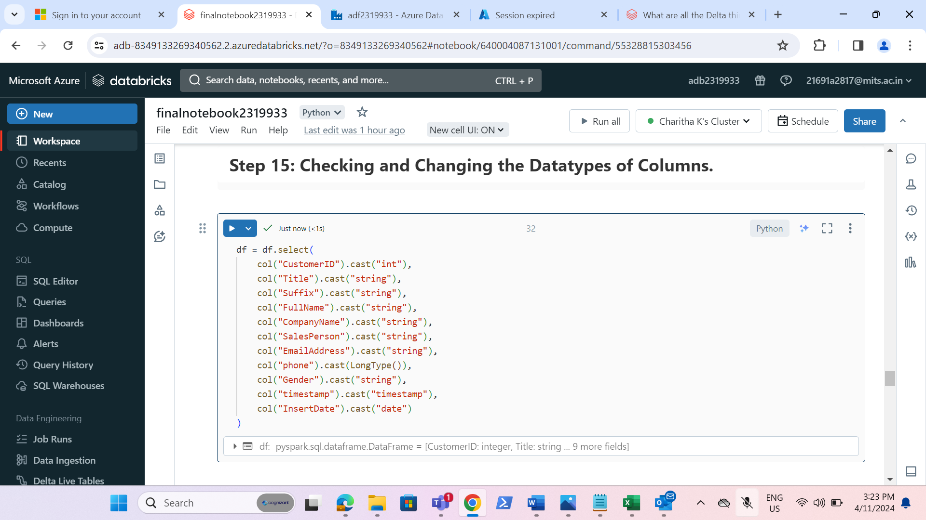

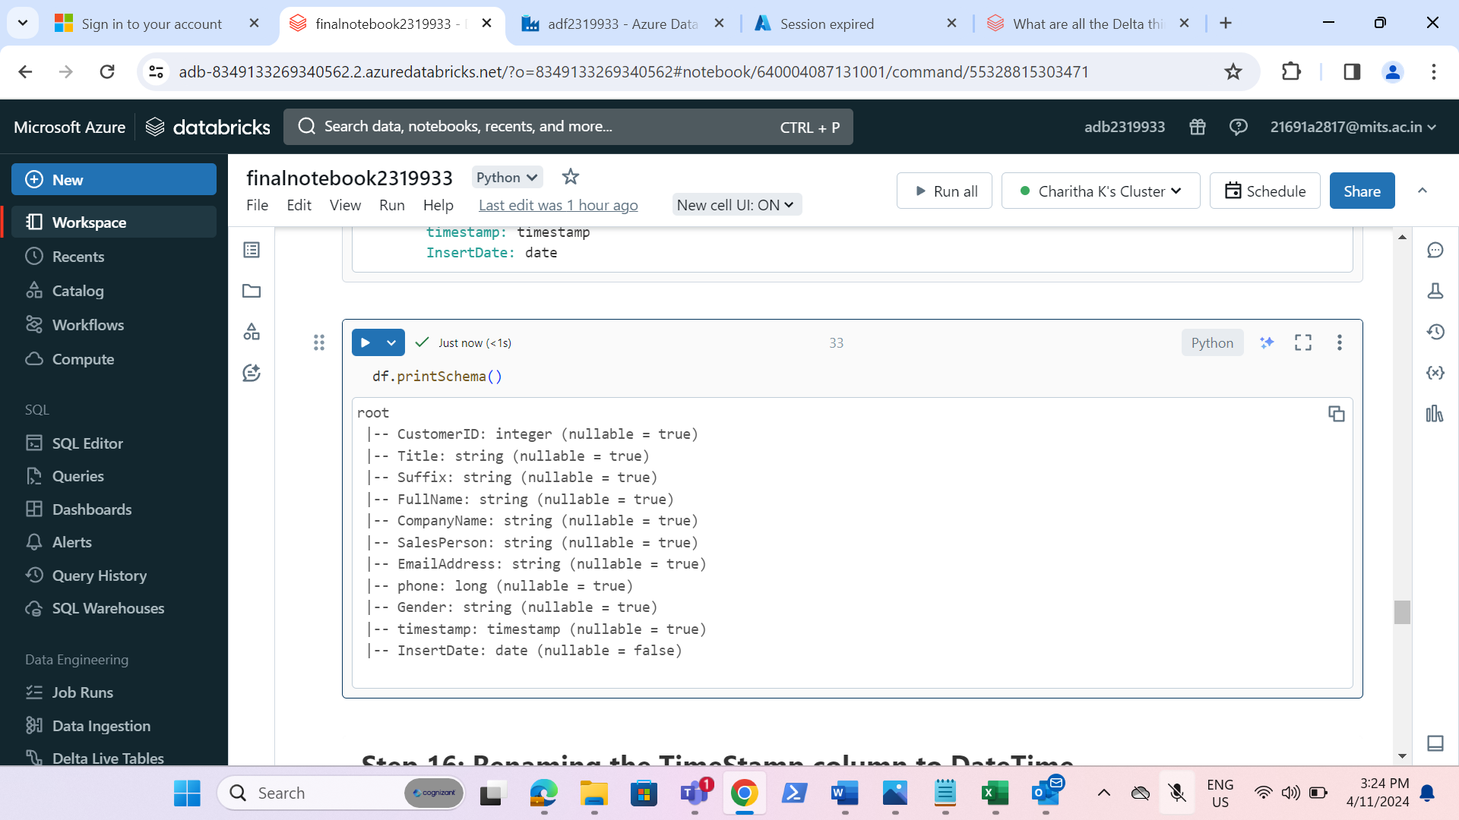

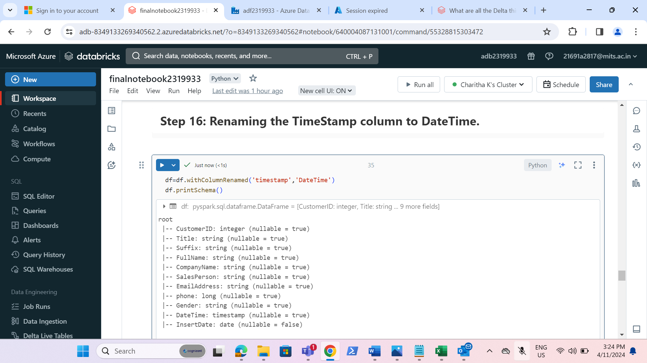

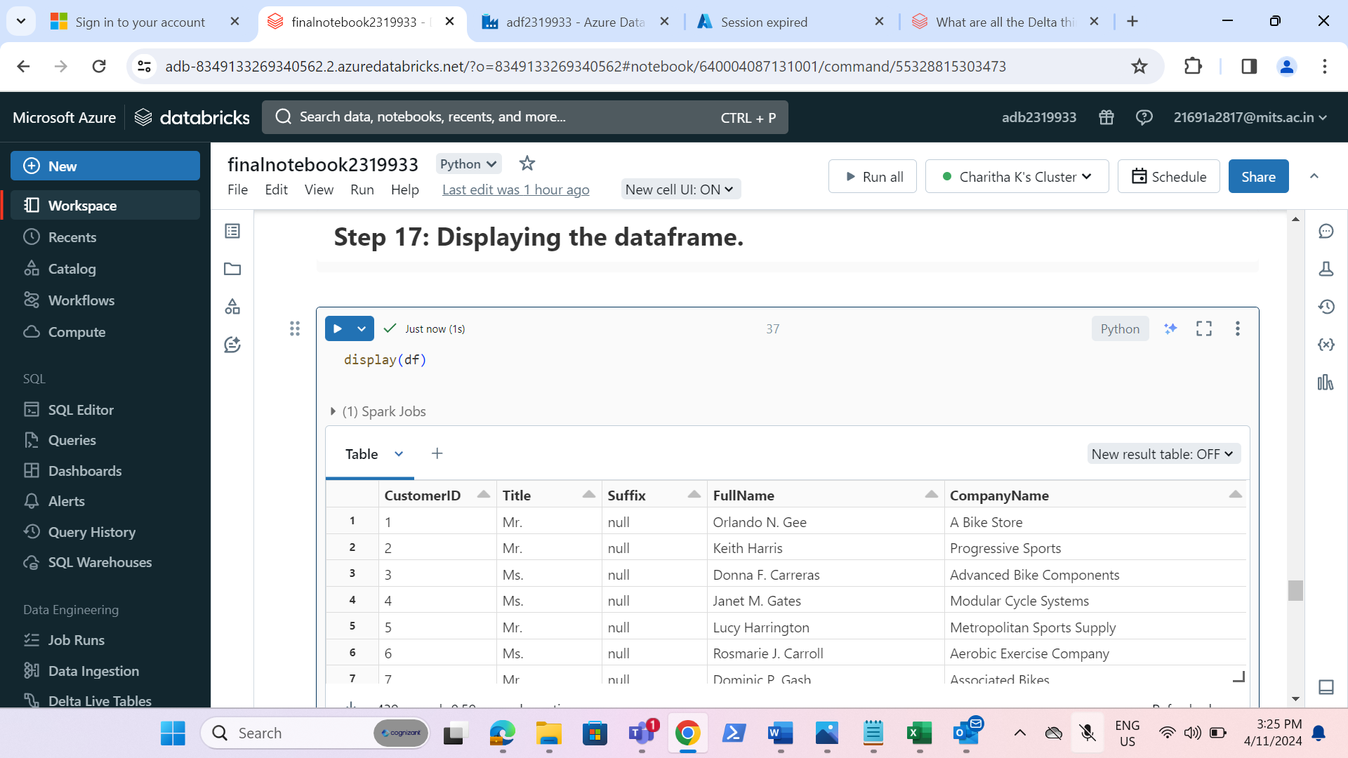

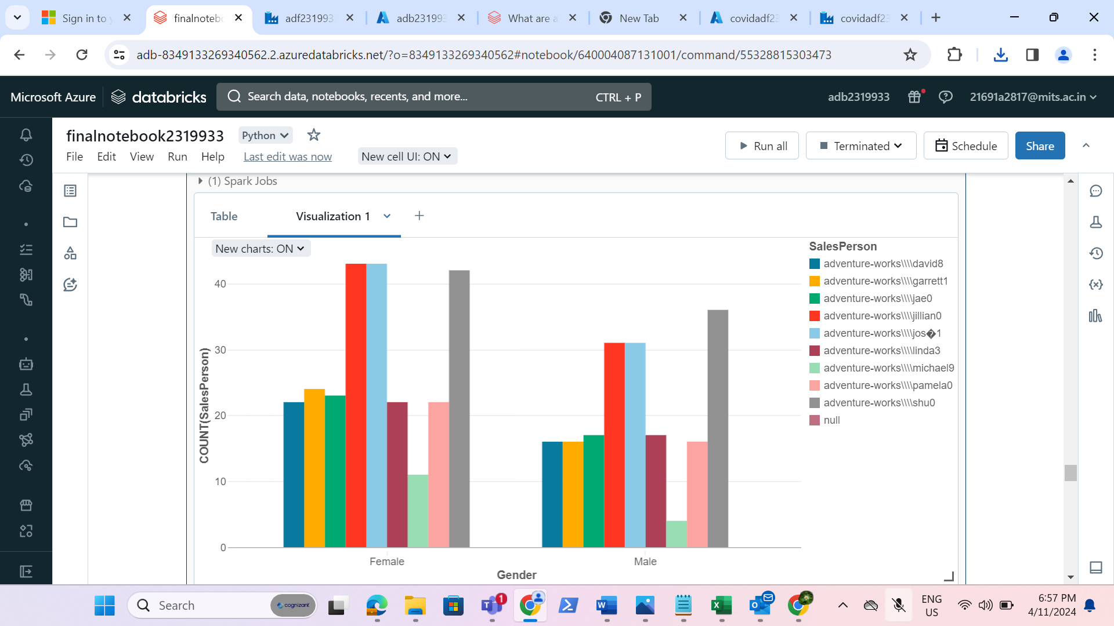

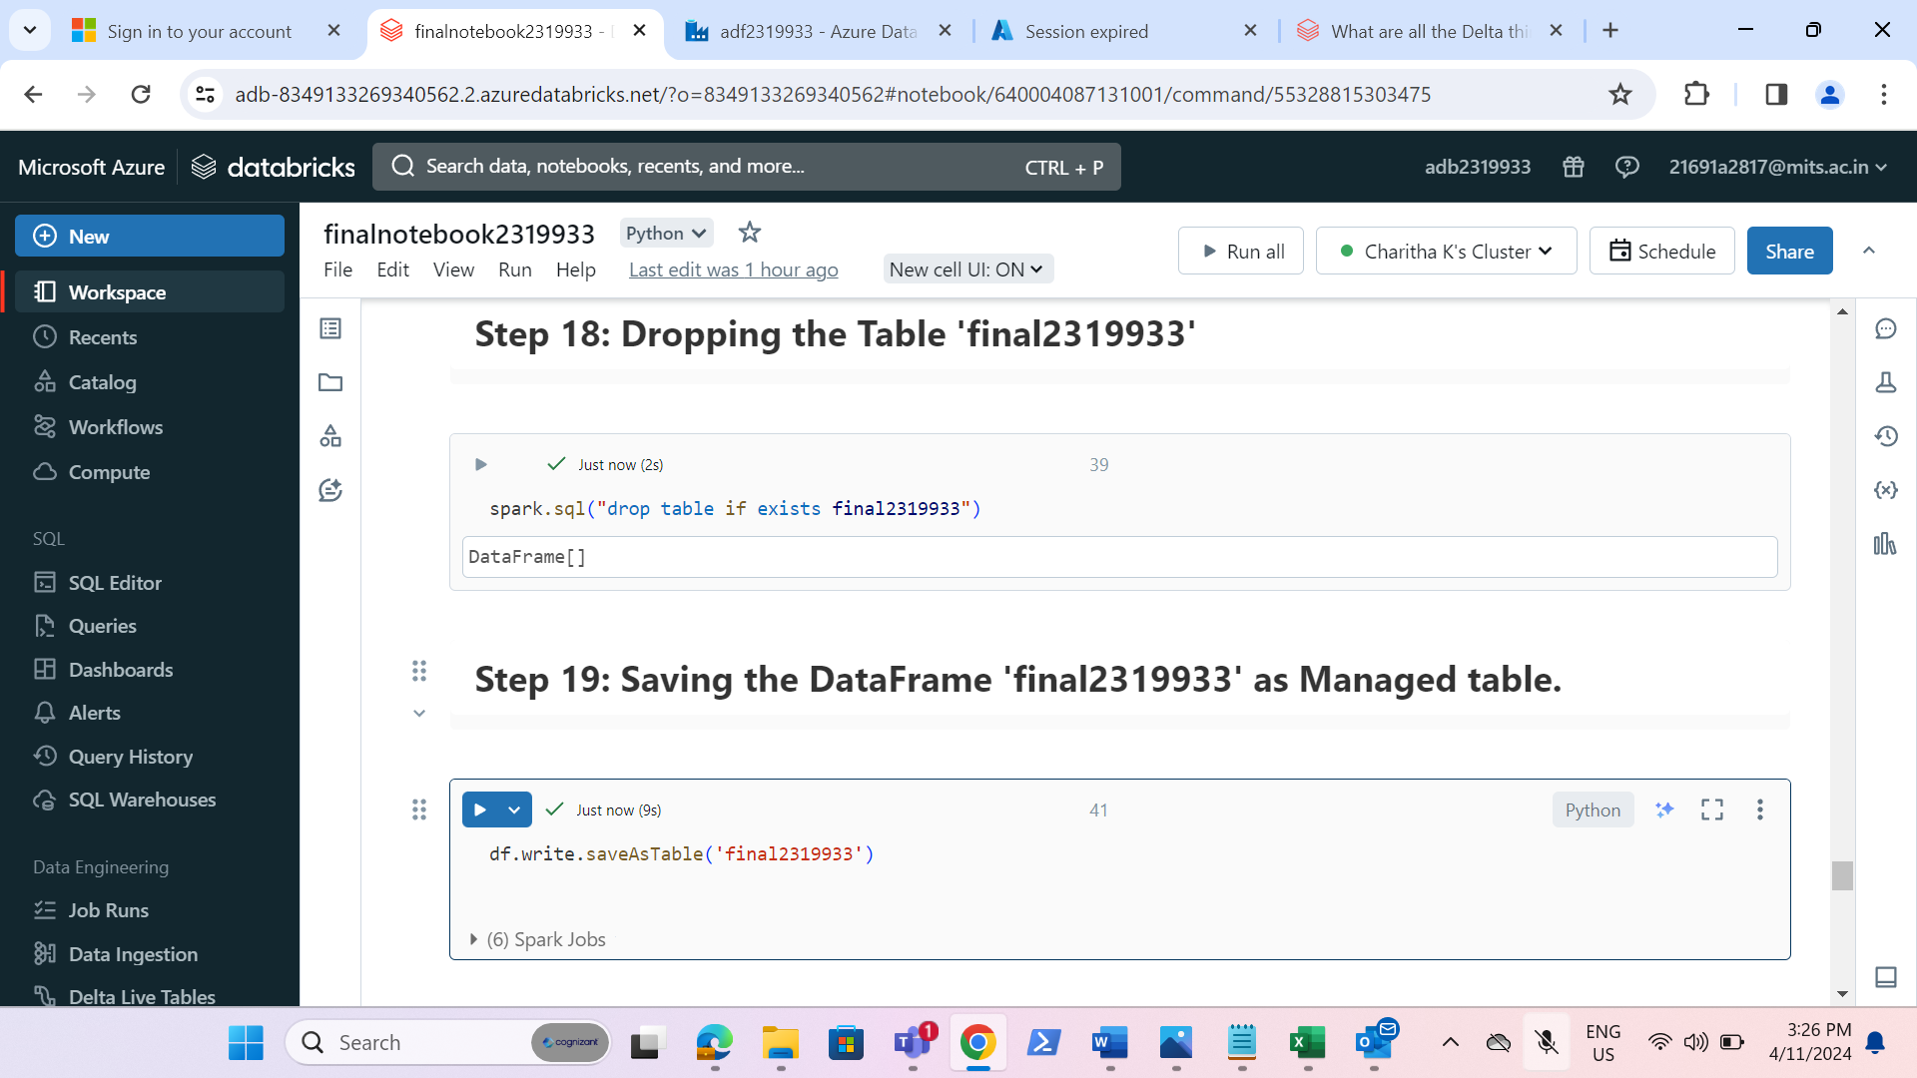

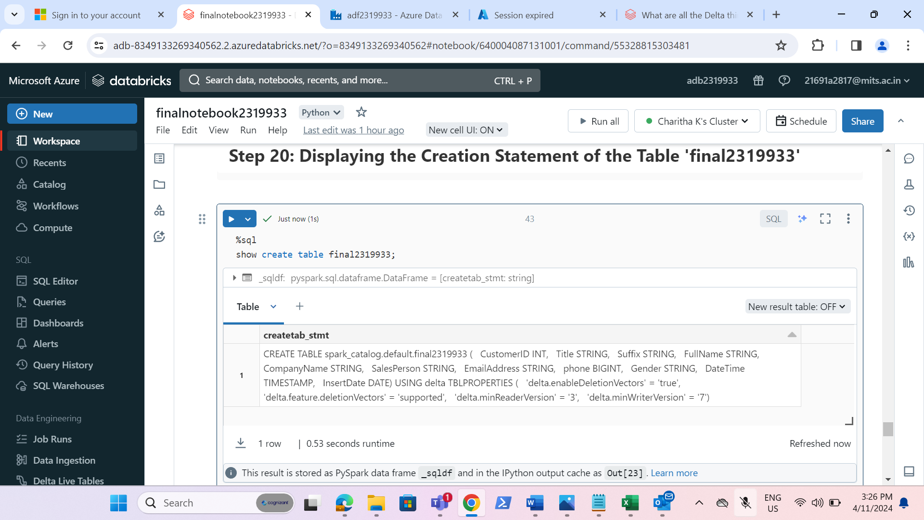

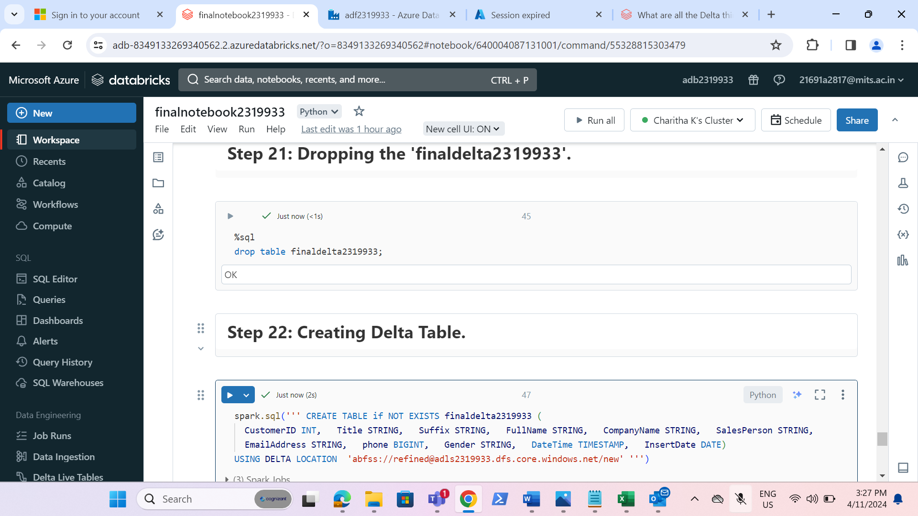

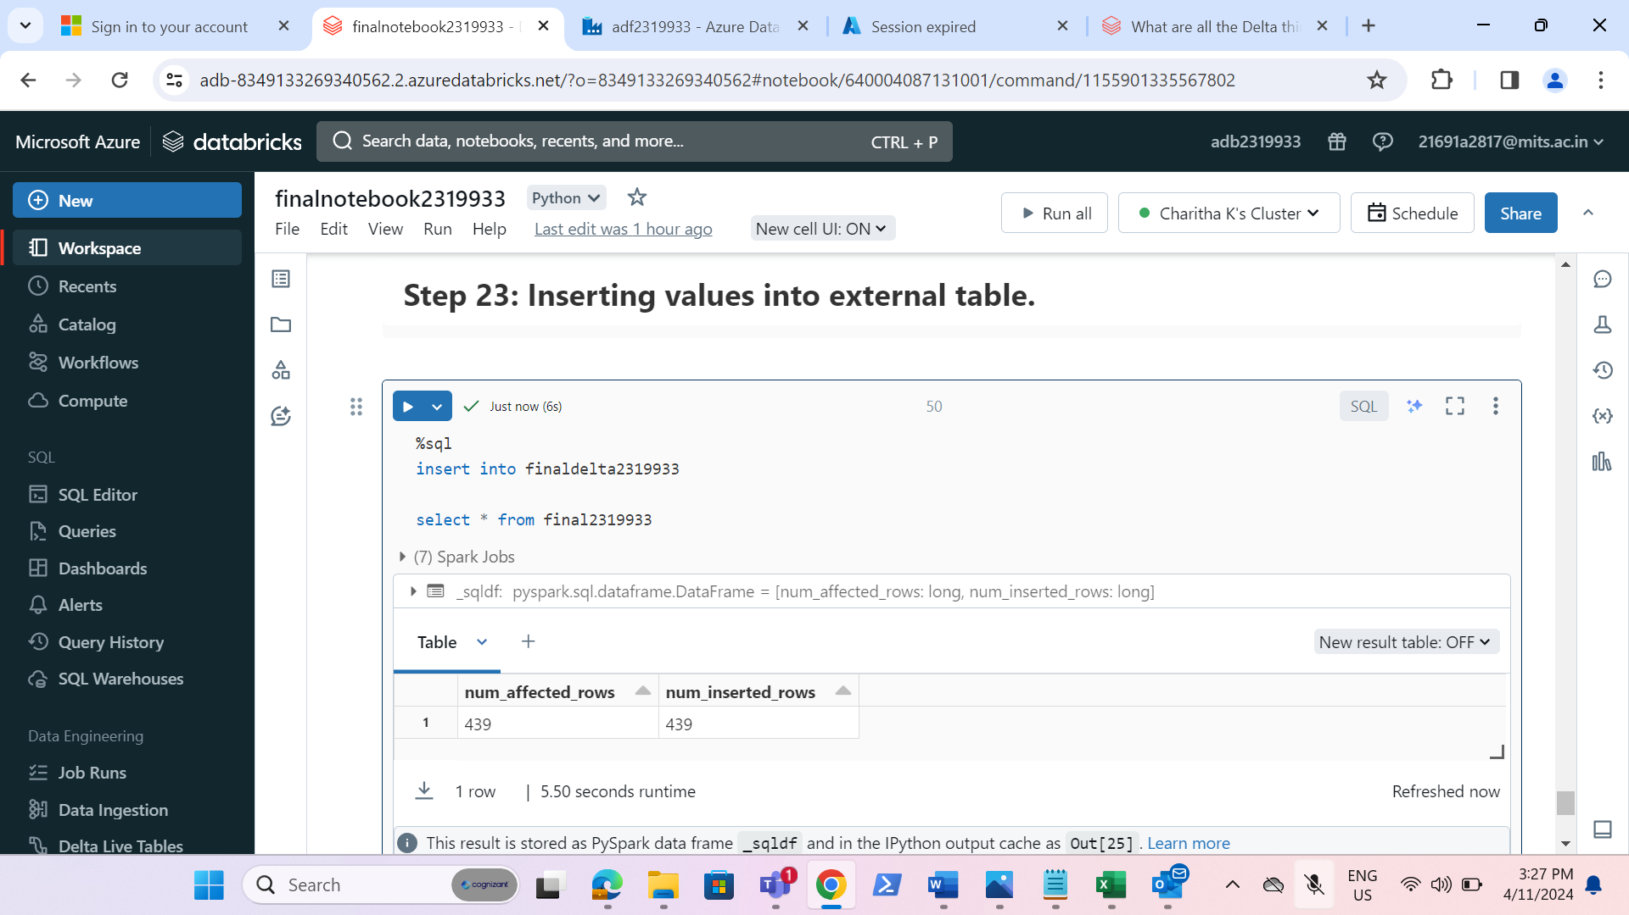

**REQUIREMENT 3-Data Verification(use ADF):**

* Add the notebook activity and output of foreach activity should be given to notebook activity.

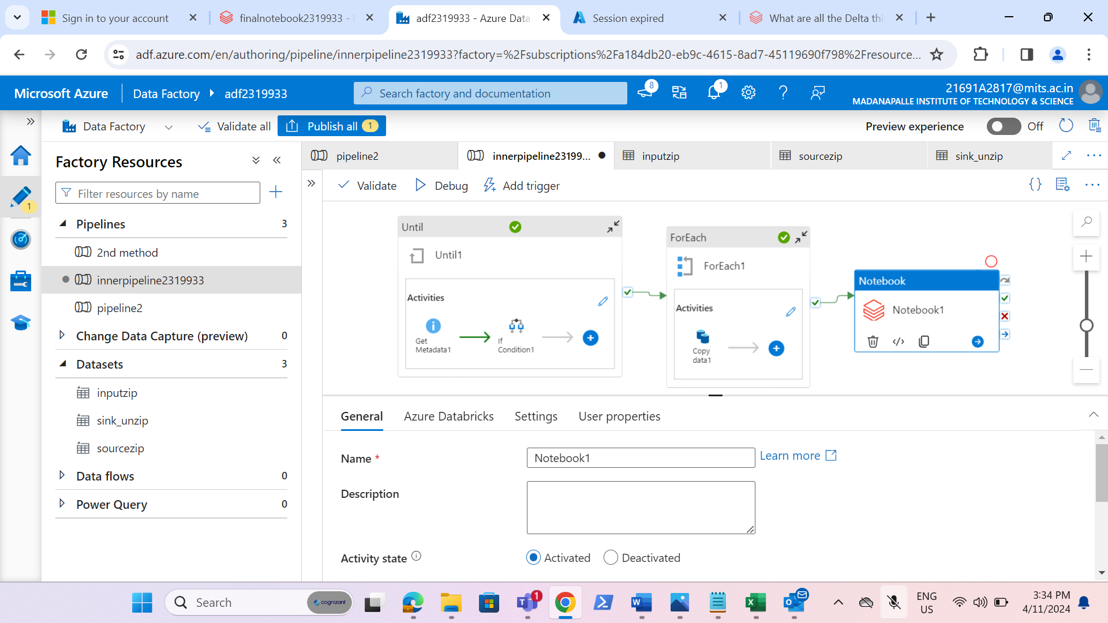

* Created a linked service for linking databricks with datalake.

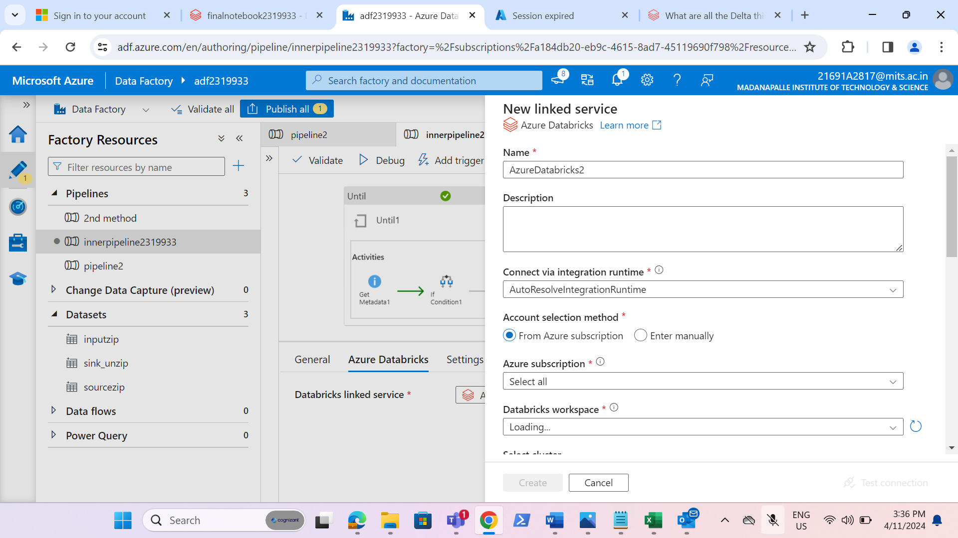

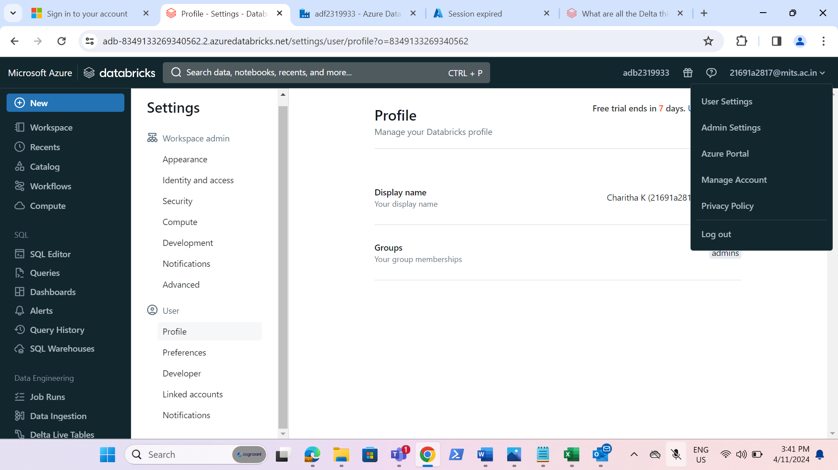

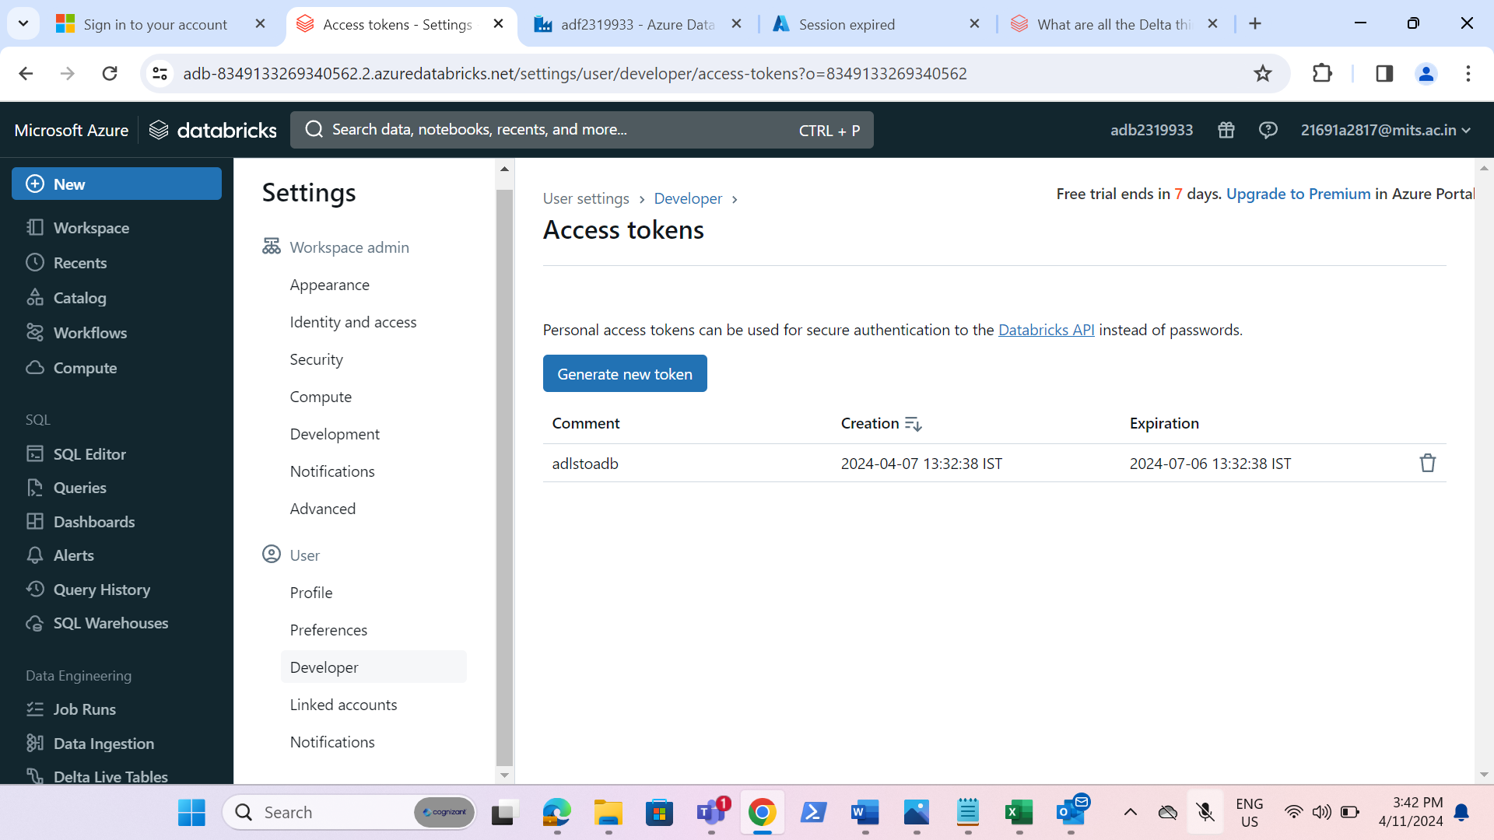

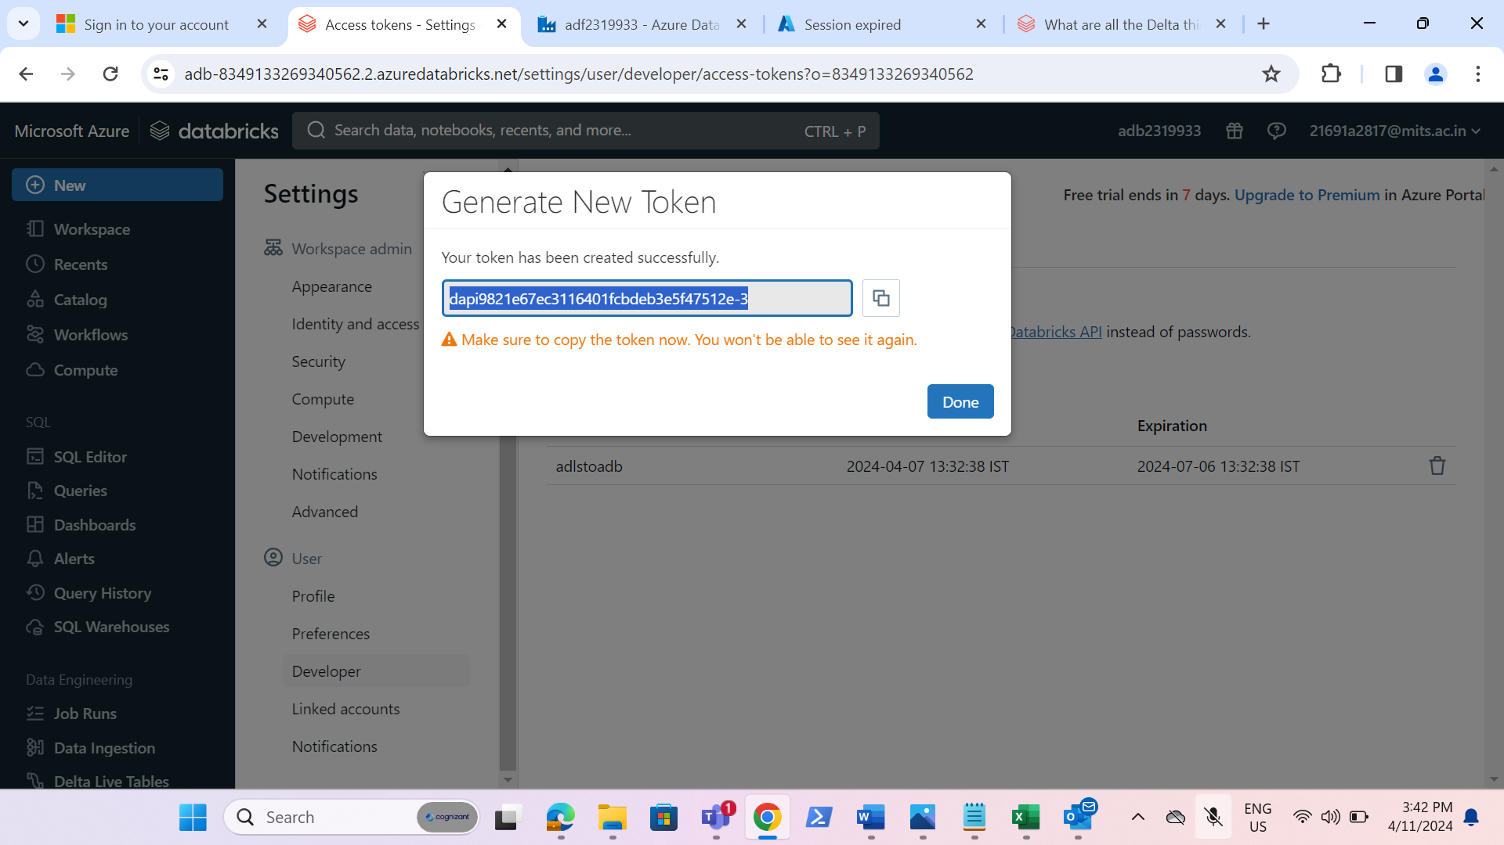

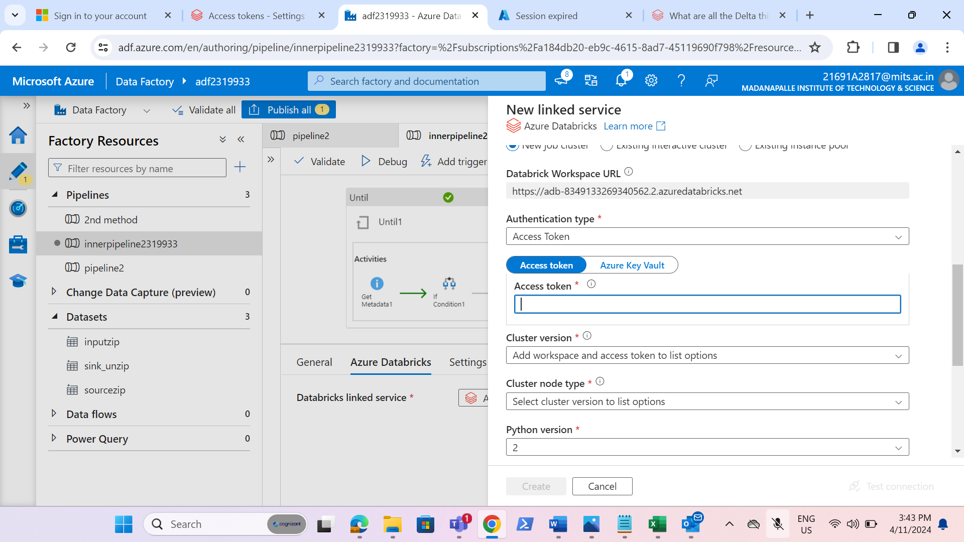

* Browse the path of the notebook.

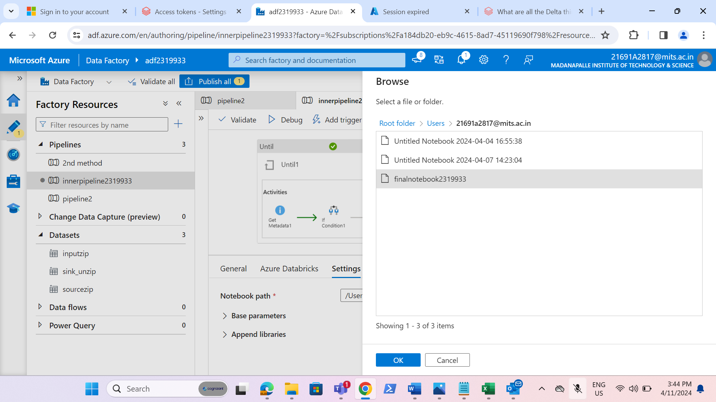

* We have successfully runned the child pipeline.

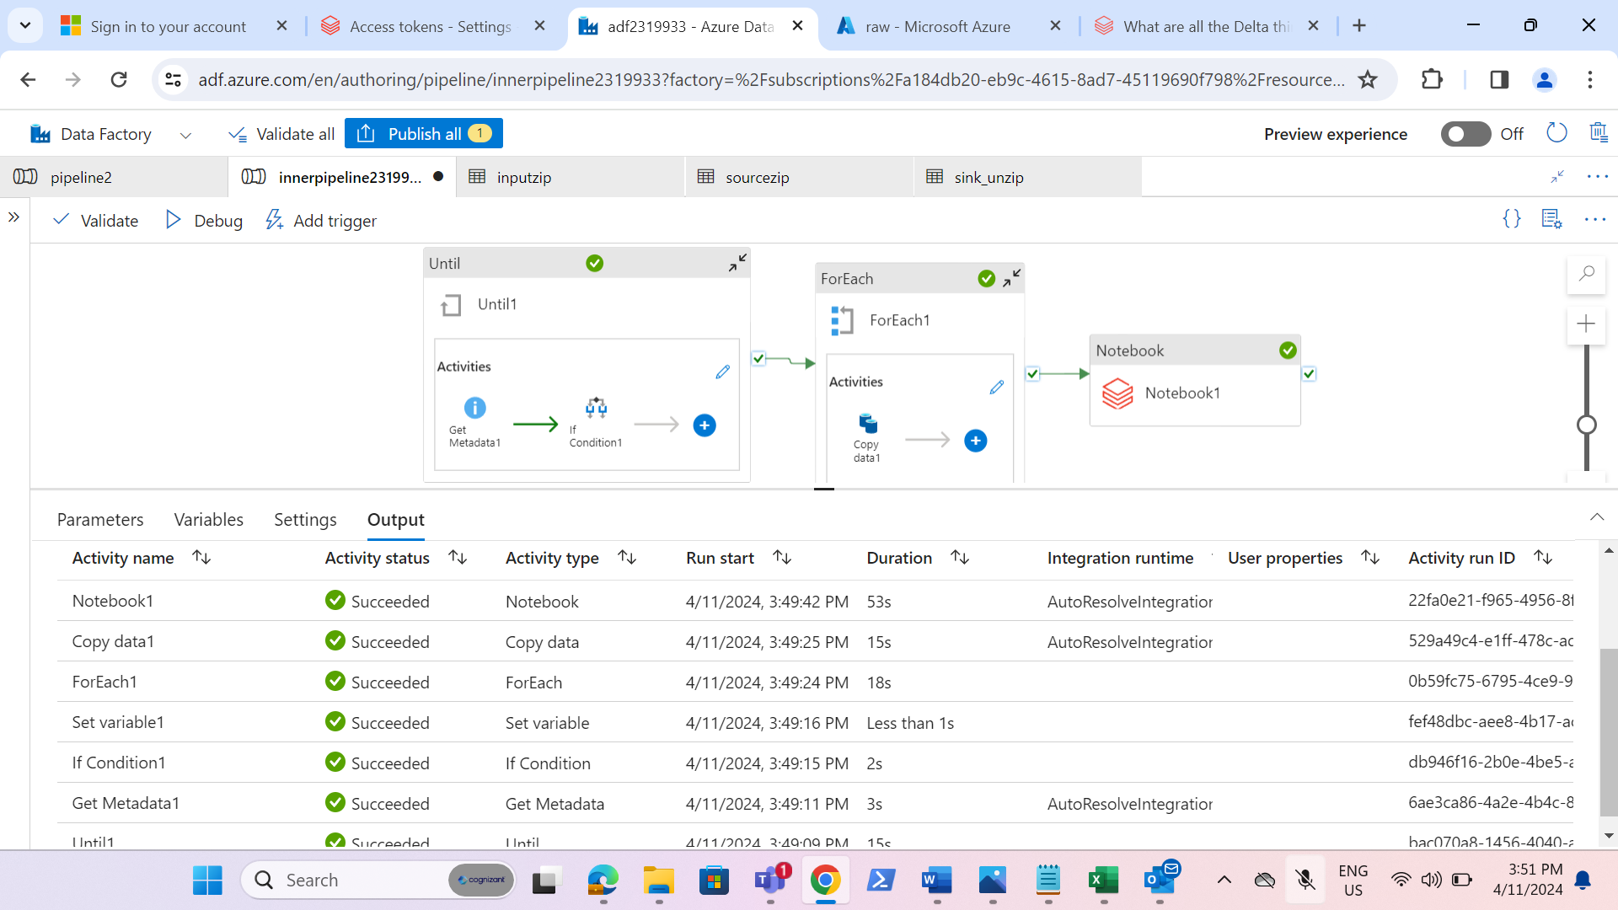

* Created the main pipeline and involve the child pipeline into main pipeline.

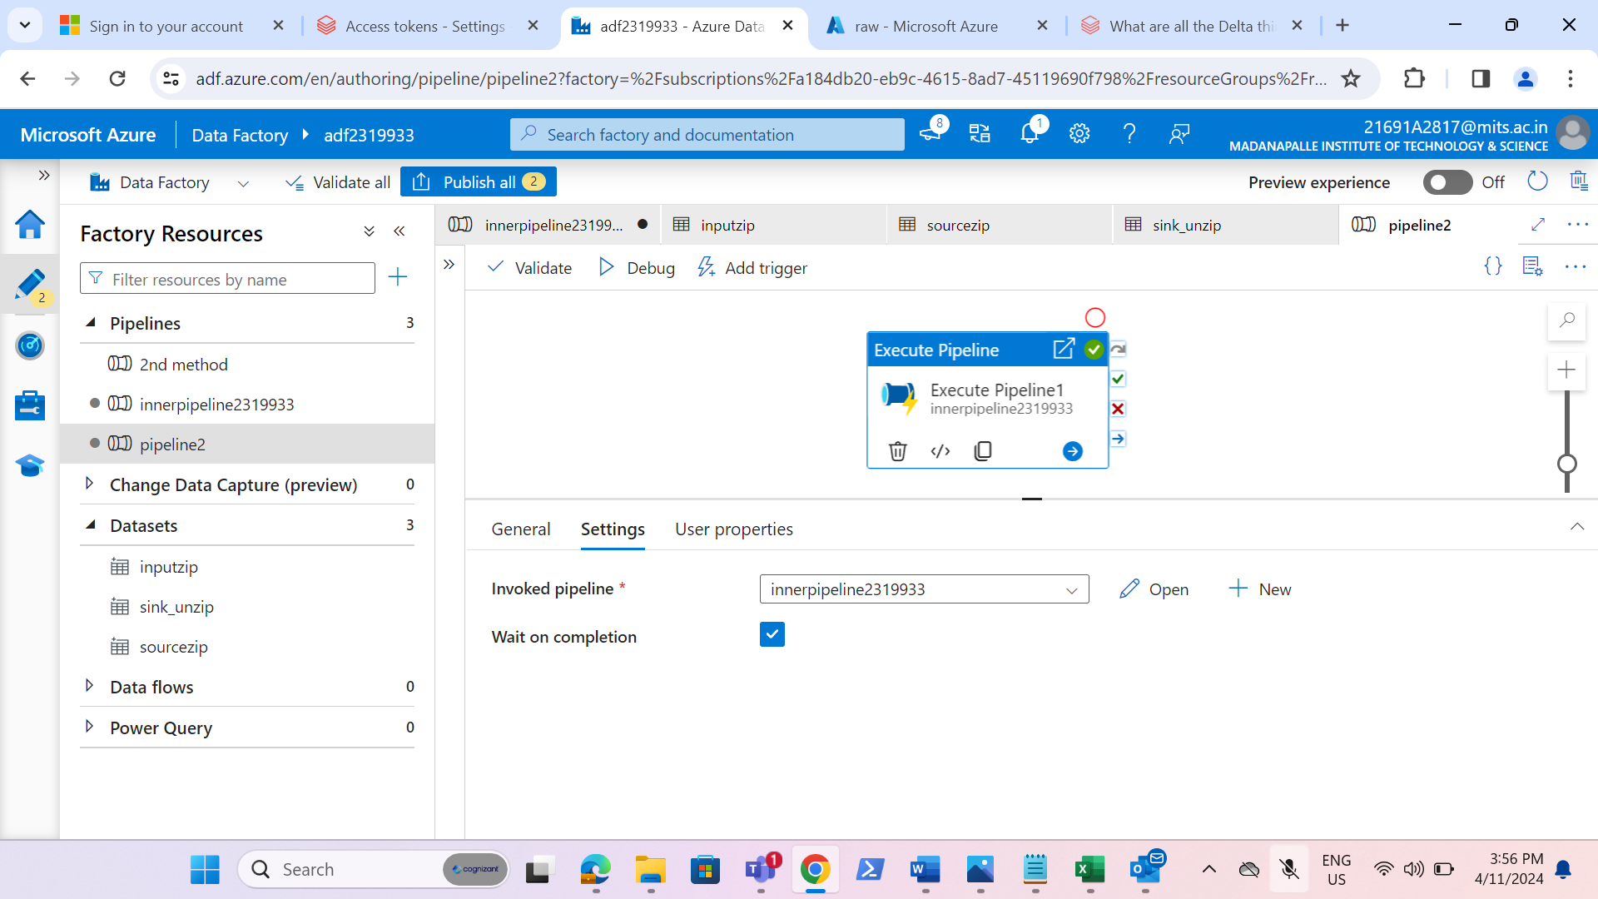

* On success and failure of the child pipeline ,added the web activities to trigger the mail on both success and failure and creating a parameter at a pipeline level and setting the default value as email.

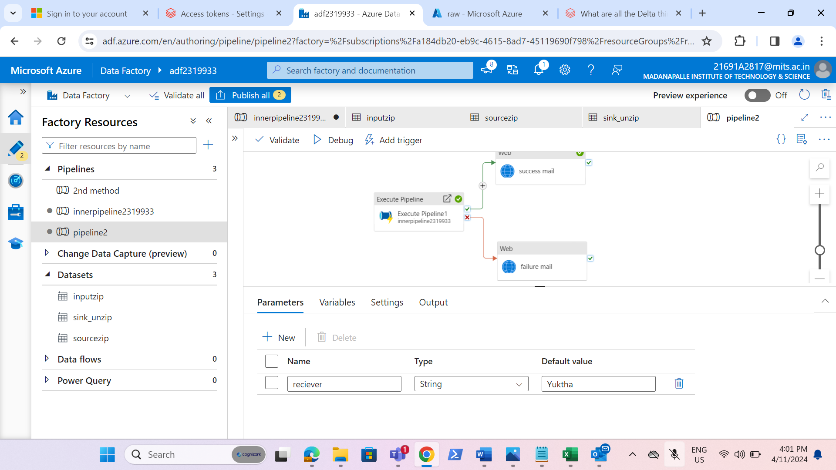

* Create the logic app.

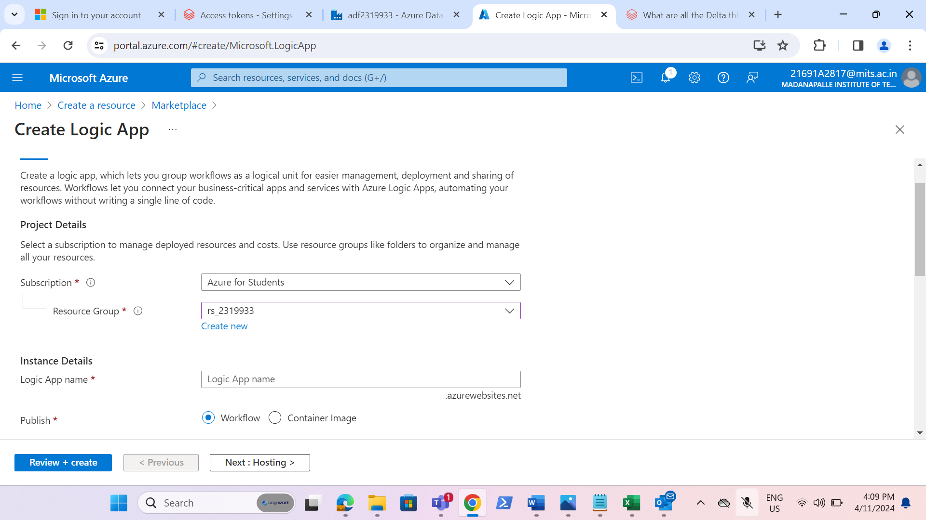

* Go to logic app designer and click on trigger.

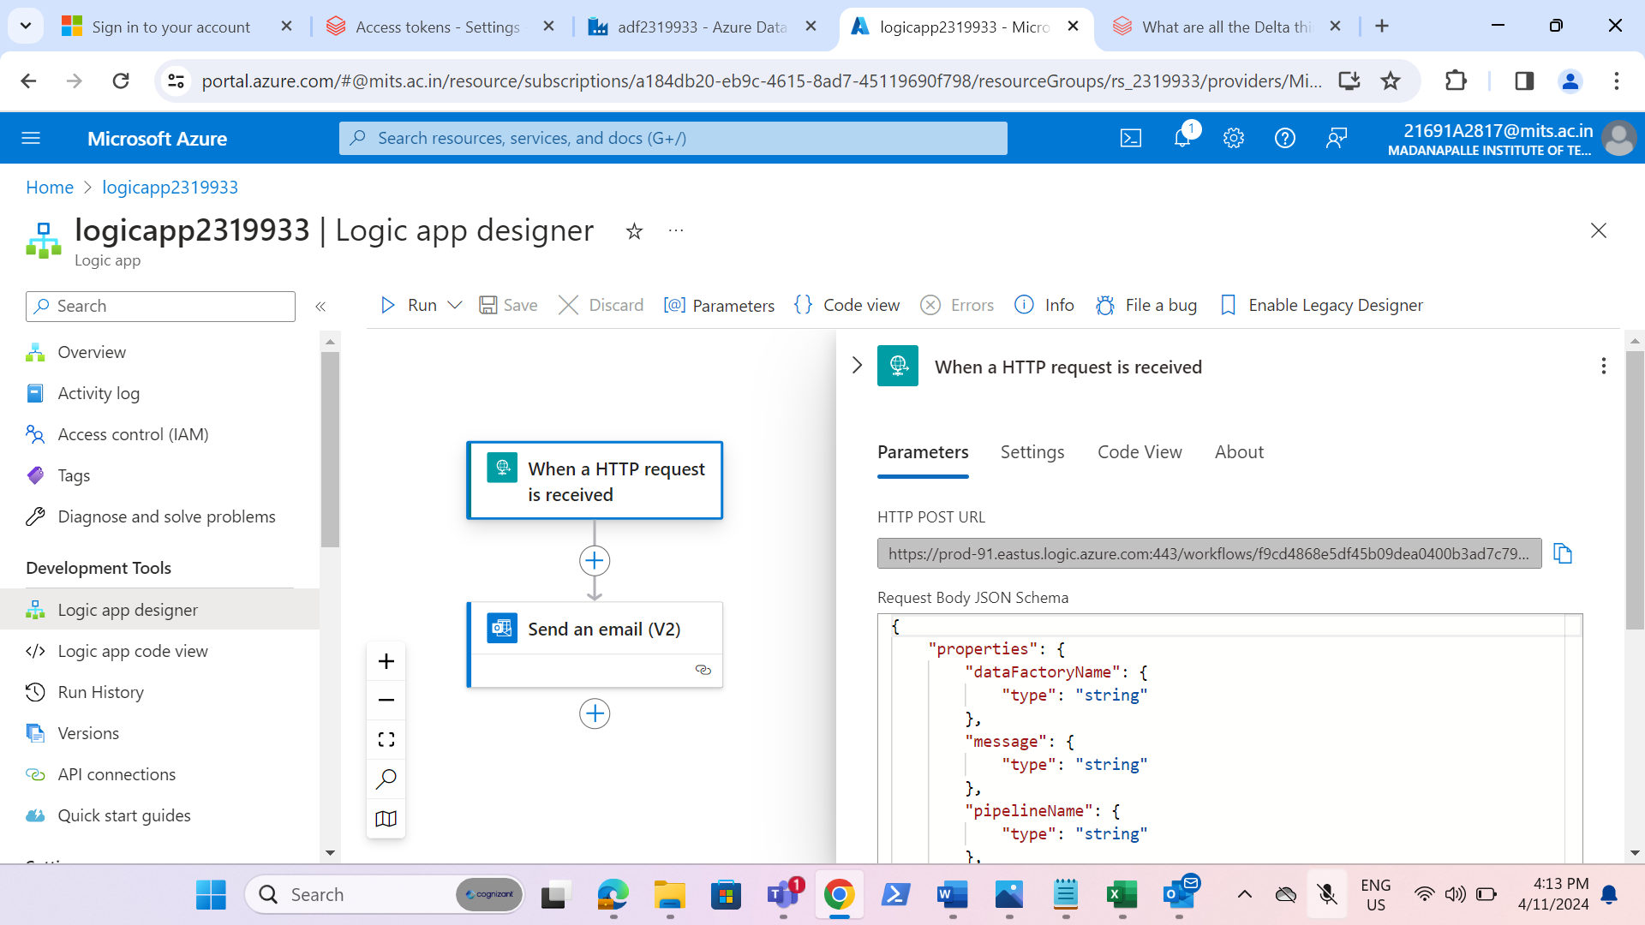

* Give the http request and when request is received, trigger the mail.

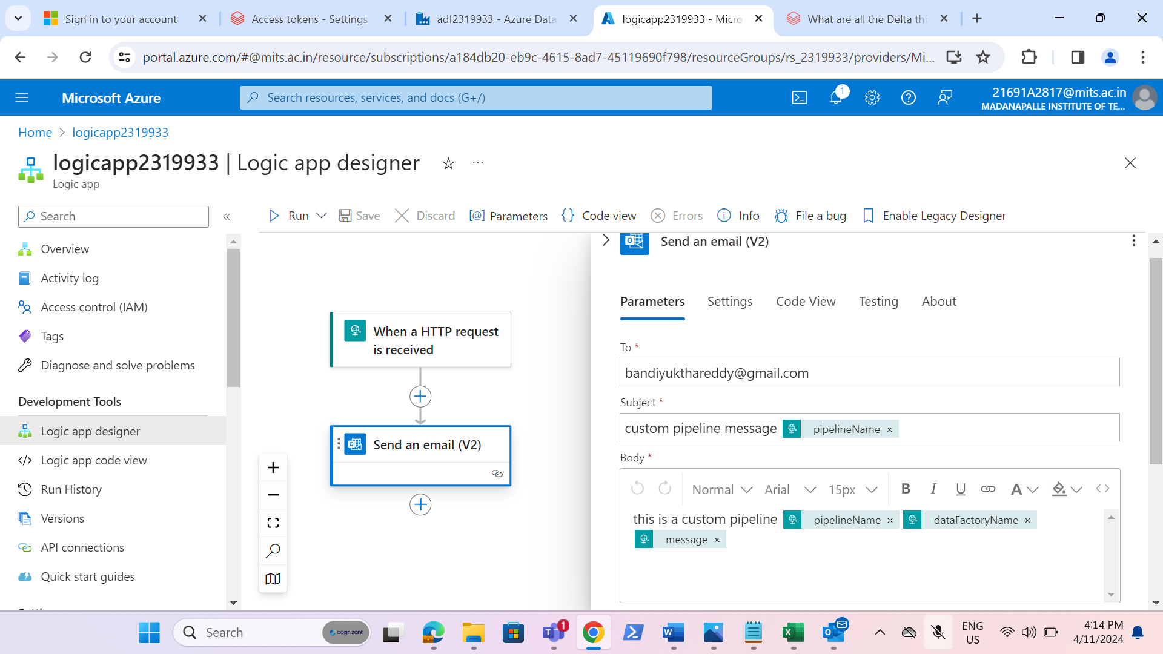

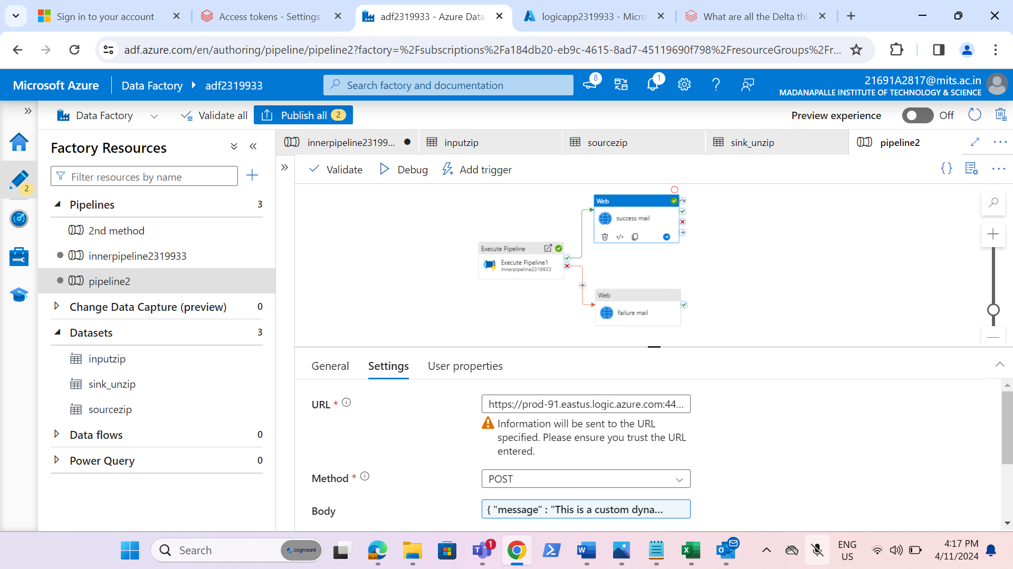

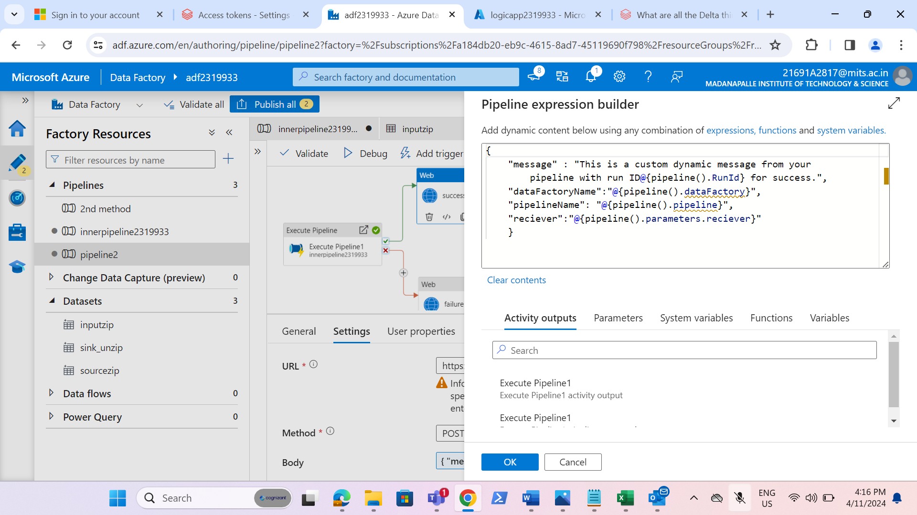

* Go to web activity on success, give the url of http request that we have copied in the logic app designer.
* Select the method as POST.
* In the body, give the message that we should receive on success of pipeline.

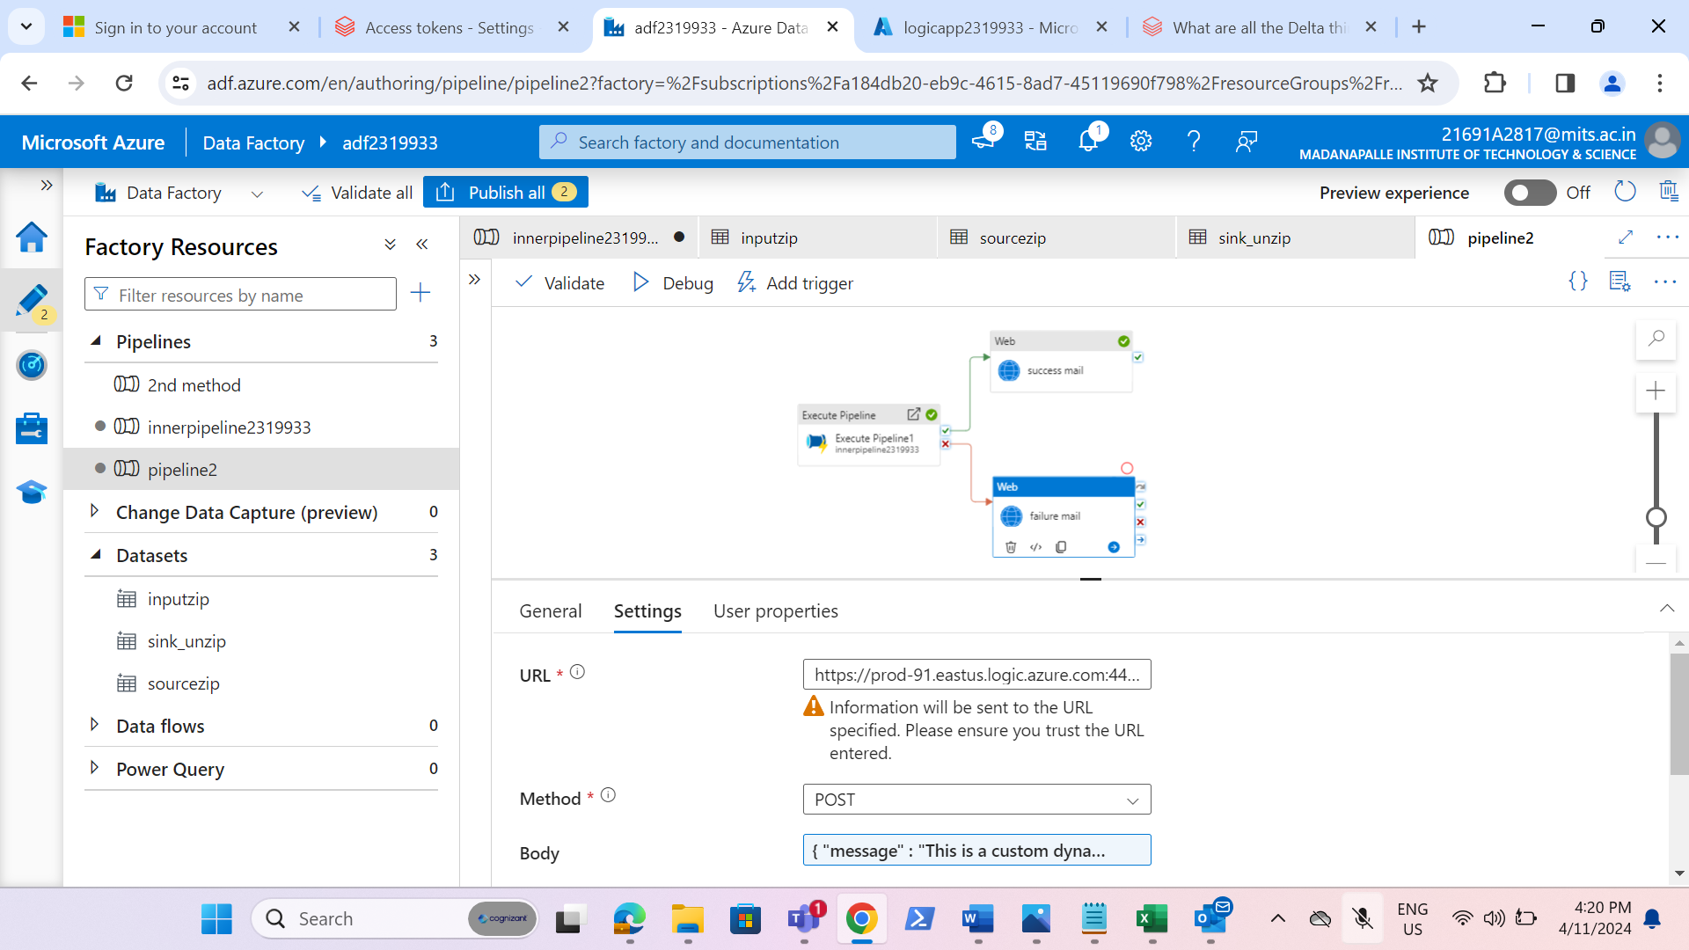

* Do the same as above by taking one more web activity for failure activity.

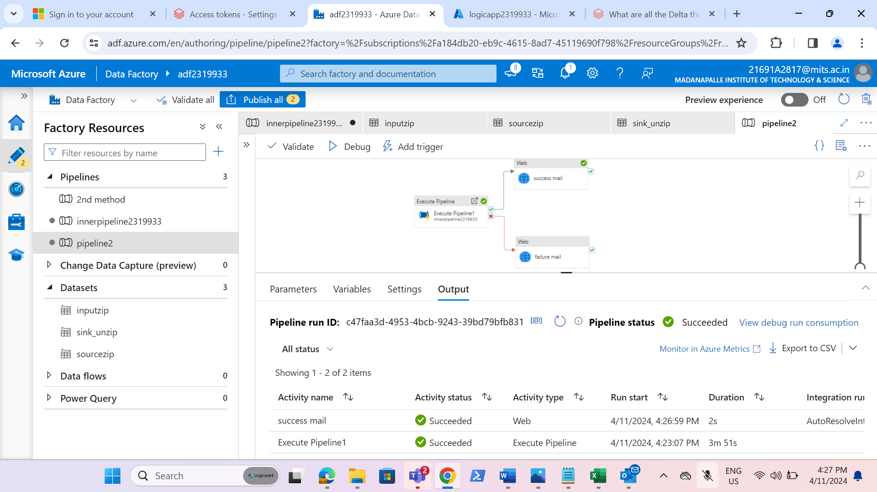

* On success or failure of pipeline, we will receive the mail.

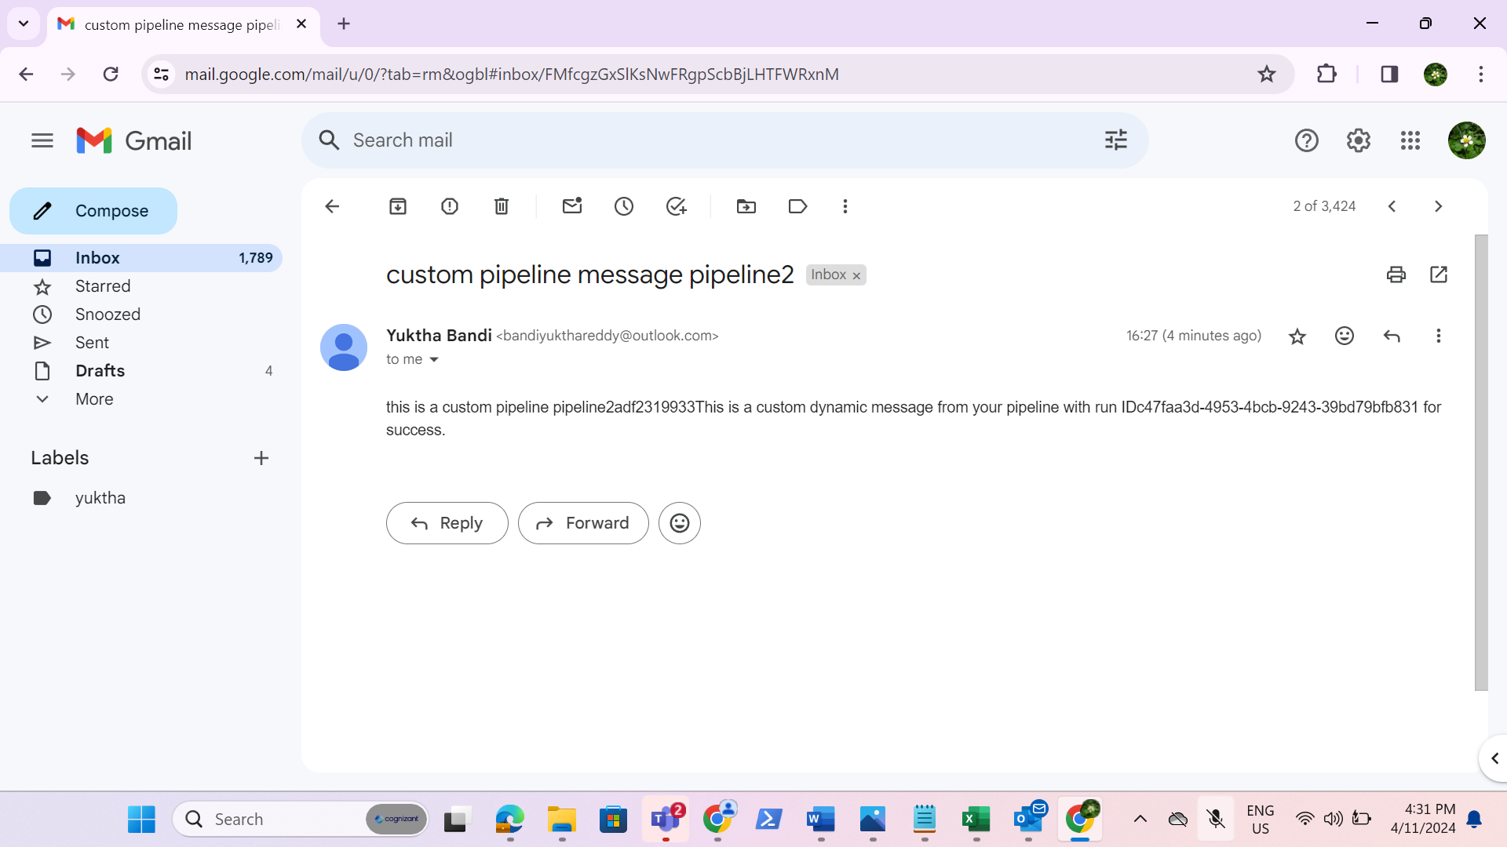

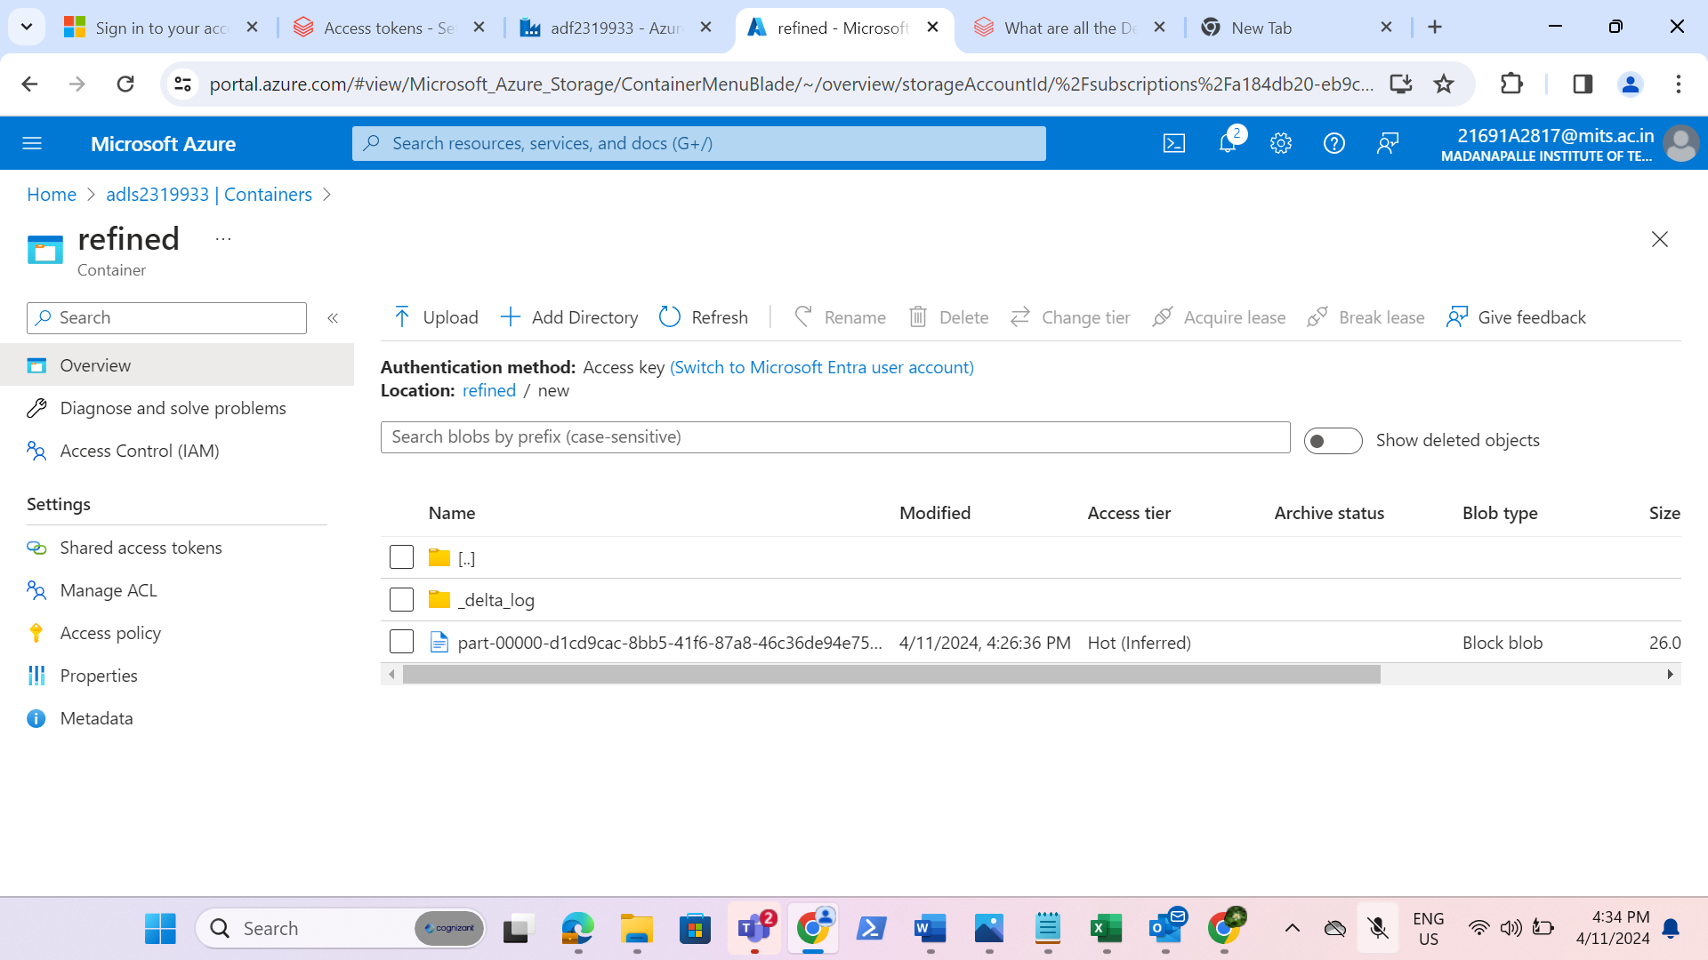

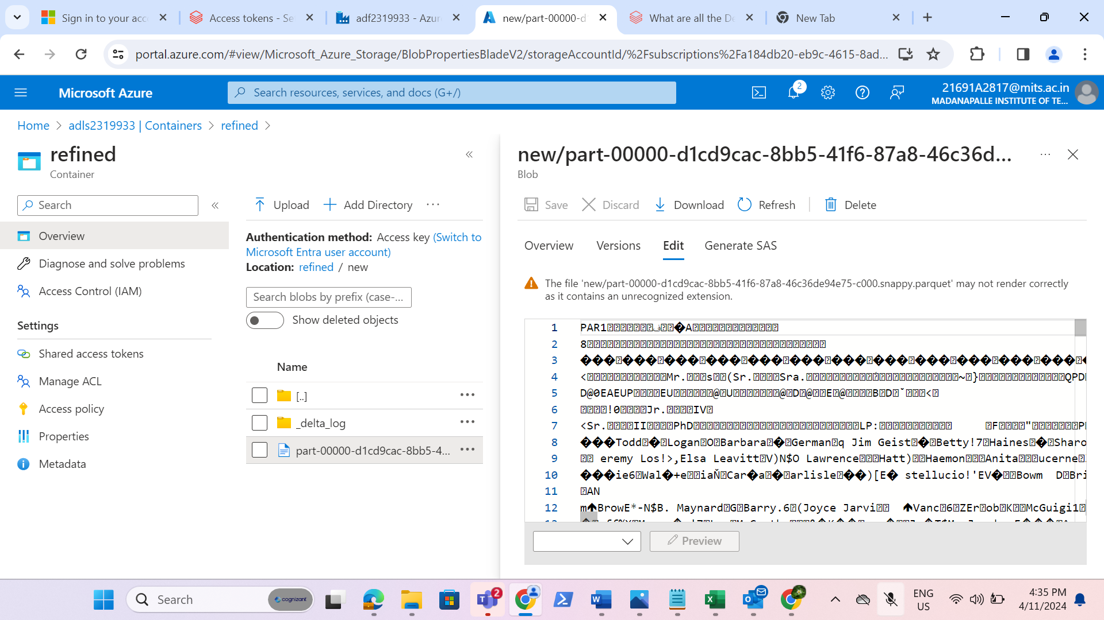

* Now, we have successfully got the parquet file in the refined container in the datalake.